

Management & Science University

University Drive, Off Persiaran Olahraga

Section 13, 40100 Shah Alam

Selangor Darul Ehsan

**THESIS MANAGEMENT & EVALUATION SYSTEM**

(THEMES)

USER MANUAL for FACULTY USER

Version 1.0

Document Reference: MSU/THEMES/UM/002

**DOCUMENT DETAILS**

|  |  |
| --- | --- |
| **Effective Date:** | 01May 2015 |
| **Document Owner:** | Information Technology and Innovation Centre (ITIC) |

**REVISION HISTORY**

|  |  |  |  |
| --- | --- | --- | --- |
| **Date** | **Version** | **Description** | **Author** |
| 18 Feb 2015 | 0.1 | Document creation | Zuraimi, Amalina |
| 02 Mar 2015 | 0.2 | Document review and update | Zuraimi |
| 30 Nov 2015 | 1.0 | Final | Zuraimi , Nizam |

**TABLE OF CONTENTS**

1 INTRODUCTION 1

1.1 Scope 1

1.2 System Requirement 2

1.2.1 URL 2

1.2.2 Internet Browser 2

1.2.3 User Access 2

1.3 Screen Design 2

2 HIGHLEVEL FLOW 4

2.1 Thesis Proposal Submission Process Flow 4

2.2 Defence Proposal Process Flow 4

2.3 Work Completion Process Flow 6

2.4 VIVA Evaluation Process Flow 7

3 MODULE and FEATURE 9

3.1 Available Module and Feature for Student 9

4 MAIN 11

4.1 Announcement 11

5 LOGIN and LOGOUT 12

5.1 Login 12

5.2 Logout 13

6 THESIS 14

6.1 List of Thesis 14

6.2 Student Profile 16

6.2.1 Student Profile 17

6.2.2 Supervisor/Co-Supervisor List 18

6.2.3 Subject Taken 18

6.2.4 Thesis History 19

6.3 Thesis Profile 21

6.3.1 Student Profile Details 22

6.3.2 Supervisor/Co-Supervisor List 22

6.3.3 Subject Taken 24

6.3.4 Thesis History 25

7 MONTHLY PROGRESS REPORT 26

7.1 List Monthly Progress Report 26

8 WORK COMPLETION 28

8.1 Verify Amendment 28

9 THESIS EVALUATION / VIVA 30

9.1 Amendment Review 30

9.2 List of Appeal 32

9.3 List of Amendment Result 34

10 ADMINISTRATION 36

10.1 Assign Evaluation Panel 36

10.2 Schedule Evaluation Session 38

10.3 Reviewer Feedback Approval 42

10.3.1 Feedback by Reviewer 42

10.3.2 Feedback Due – Request Extension Approval 44

10.4 Unassign Supervisor 45

10.5 Proposal Confirmation 48

10.6 Proposal Cancellation 52

10.7 Assign Reviewer 54

10.7.1 Assign Reviewer 54

10.7.2 Assign Reviewer via Proposal Confirmation 57

10.8 Assign Supervisor 58

10.8.1 Assign Supervisor 58

10.8.2 Assign Supervisor via Proposal Confirmation 63

10.9 List of Thesis Proposal – Disapproved 64

11 Message 65

11.1 Inbox 65

11.1.1 New and Read Message 65

11.1.2 Delete Message 67

11.2 New Message 68

11.2.1 Send Message 68

11.2.2 Select Recipient 69

11.2.3 Upload Attachment - Add 71

11.2.4 Upload Attachment - Update 73

11.2.5 Upload Attachment - Delete 74

11.3 Sent Message 75

11.3.1 View Sent Message 75

11.3.2 Delete Sent Message 76

12 Control Panel 77

12.1 Change Password 77

12.1.1 Before Login 77

12.1.2 After Login 79

13 Help 80

13.1 Online Help - Student 80

13.2 User Manual 82

13.3 Frequently Asked Question 83

13.4 About Us 84

**LIST OF FIGURES**

Figure 1: Manual Structure 1

Figure 2: THEMES Screen Structure Design 3

Figure 3: Thesis Proposal Submission Process Flow 4

Figure 4: Defence Proposal Submission Process Flow 5

Figure 5: Work Completion Process Flow 6

Figure 6: VIVA Evaluation Process Flow 8

Figure 7: Modules and Features 10

Figure 8: Announcement 11

Figure 9: Login Page 12

Figure 10: Logout Page 13

Figure 11: Thesis Tab – List of Thesis 14

Figure 12: Thesis Tab 16

Figure 13: Student Profile Tab 17

Figure 14: List of Supervisor / Co-Supervisor 18

Figure 15: Subject Taken 19

Figure 16: Thesis Tab – Thesis History 20

Figure 17: Thesis Tab – List of Student 21

Figure 18: Thesis Tab – Student Profile 22

Figure 19: Thesis Tab - List of Supervisor / Co-Supervisor 23

Figure 20: Thesis Tab - Subject Taken 24

Figure 21: Thesis Tab – Thesis History 25

Figure 22: List Monthly Progress Report 26

Figure 23: Verify Amendment 29

Figure 24: Amendment Review 31

Figure 25: Appeal Request 33

Figure 26: List of Amendment Result 34

Figure 27: Assign Evaluation Panel 37

Figure 28: Schedule Evaluation Session 40

Figure 29: Administration Tab – Reviewer Feedback Approval 43

Figure 30: Feedback Extension Approval 44

Figure 31: Unassign Supervisor 47

Figure 32: Administration Tab – Proposal Confirmation 50

Figure 33: Administration Tab – Proposal Cancellation 53

Figure 34: Assign Reviewer 55

Figure 35: Assign Reviewer via Proposal Confirmation 57

Figure 36: Administration Tab – Assign Supervisor Page 61

Figure 37: Administration Tab – Assign Supervisor via Proposal Confirmation 63

Figure 38: Administration Tab – List of Disapproved Thesis 64

Figure 39: Message 65

Figure 40: Delete Message 67

Figure 41: New Message 68

Figure 42: Select Recipient 70

Figure 43: Upload Attachment - Add 72

Figure 44: Upload Attachment - Update 73

Figure 45: Upload Attachment - Delete 74

Figure 46: View Sent Message 75

Figure 47: Delete Sent Message 76

Figure 48: Change Password Page Before Login 78

Figure 49: Change Password Page After Login 79

Figure 50: Online Help 80

Figure 51: User Manual 82

Figure 52: FAQ 83

# INTRODUCTION

Thesis Management and Evaluation System (THEMES) version 1.0.0 is a system for the Student, Supervisor, Faculty and Senate to monitor the status of thesis proposal from its initial stage toward to the end. It is not only use by the respective personnel to control and manage the quality of the thesis to meet the university standard but it also can be used to keep track all the communication between the student and university. If required the history can be retrieved to view the completed work or its progress.

The system contains the main modules which are Thesis Proposal Submission and Approval, Monthly Progress Report Review, Thesis Proposal Defense, Thesis Work Completion, Thesis Evaluation/Viva and Senate Endorsement.

## Scope

The manual will guide the student on how to use the system in every stages starting from the thesis proposal submission, monthly report submission, defence proposal submission, work completion submission, viva evaluation and senate endorsement.

The manual is structured into the following sections:

| **Manual Section** | **Description** |
| --- | --- |
| Prerequisite | This section describes the actions or steps shall be done and in place first before the required steps can be done. |
| Steps | This section describes the steps to follow in order to yield the result for the desired function. |
| Next Action | This section describes the expected next steps to be followed once the above steps have been successfully performed. |
| Warning | This section describes the expected warning triggered by the system if the steps performed violate the business rule validation. |
| Note | This section describes the additional information which may be useful to the user while using the system. |

Figure 1: Manual Structure

## System Requirement

### URL

The system is available over the internet via the URL <http://themes.msu.edu.my> and accessible only by the registered and authorized postgraduate student and respective MSU’s staff.

### Internet Browser

It is recommended to run the system on the following internet browser

* Mozilla Firefox version 35 and above
* Microsoft Internet Explorer version 8 and above

### User Access

The postgraduate students who have been successfully registered in Campus Management System (CMS) aka KLAS2 will be automatically become THEMES user or otherwise the student needs to check with the CMS admin on his/her credential status. By default the Student Matrix Number will be the user id to access the THEMES system.

The MSU’s staff that has been identified as reviewer, supervisor or co-supervisor can access the THEMES system once the THEMES admin registered him/her into the system. By default Employee ID will be the user id to access the THEMES system.

## Screen Design

The THEMES system screen has been design into the 5 sections namely section A, B, C, D and E.

Section A to contain the THEMES **Header** in which it contains the name of the system, the user name and Logout button

Section B to contain the THEMES **Top Panel** in which it contains the list of functions for the system.

Section C to contain the THEMES **Left Panel** in which it contains the list of sub-functions resulting from the selection in Section B.

Section D to contain the THEMES **Working Area** in which it shows the page for user respond resulting from the selection in Section C.

Section E to contain the THEMES **Footer** in which it contains the university name and its copyright.

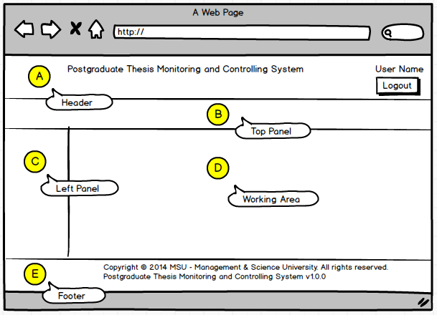

Figure 2: THEMES Screen Structure Design

# HIGHLEVEL FLOW

## Thesis Proposal Submission Process Flow

The figure below depicts the highlevel process flow for the thesis proposal submission which cover from the submission until its get approved by the Senate.

The dotted line as shown below is the area covered in this manual.

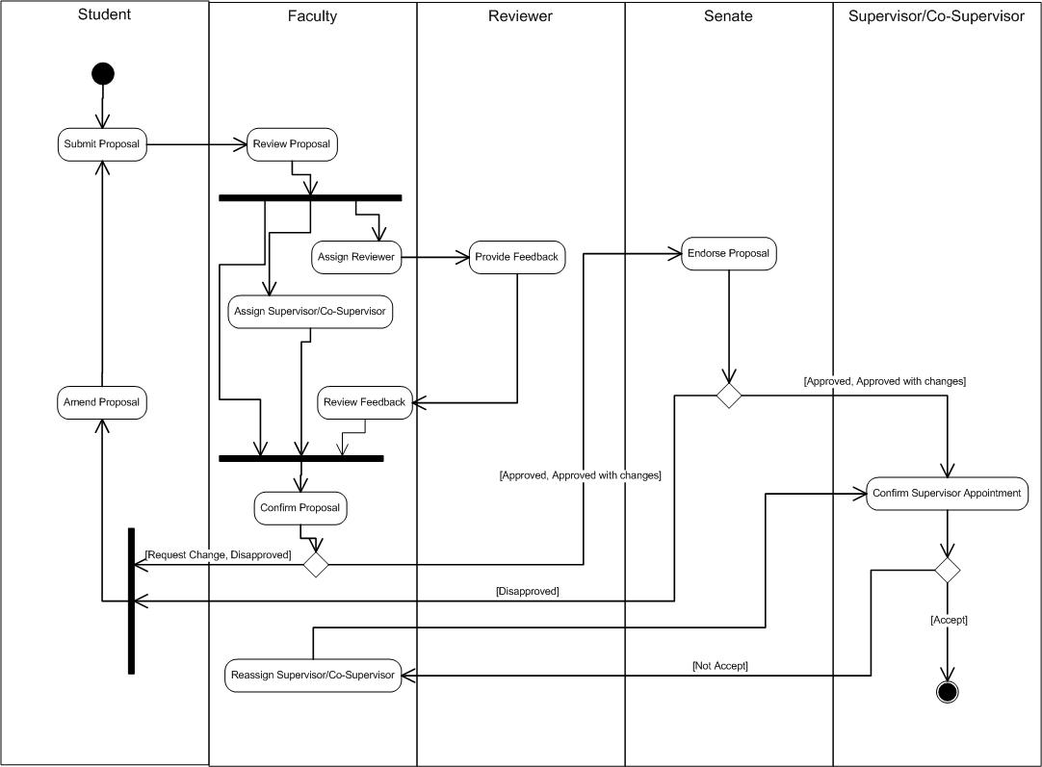

Figure 3: Thesis Proposal Submission Process Flow

## Defence Proposal Process Flow

The figure below depicts the highlevel process flow for the defence proposal submission which cover from the submission until its get approved by the Senate.

The dotted line as shown below is the area covered in this manual.

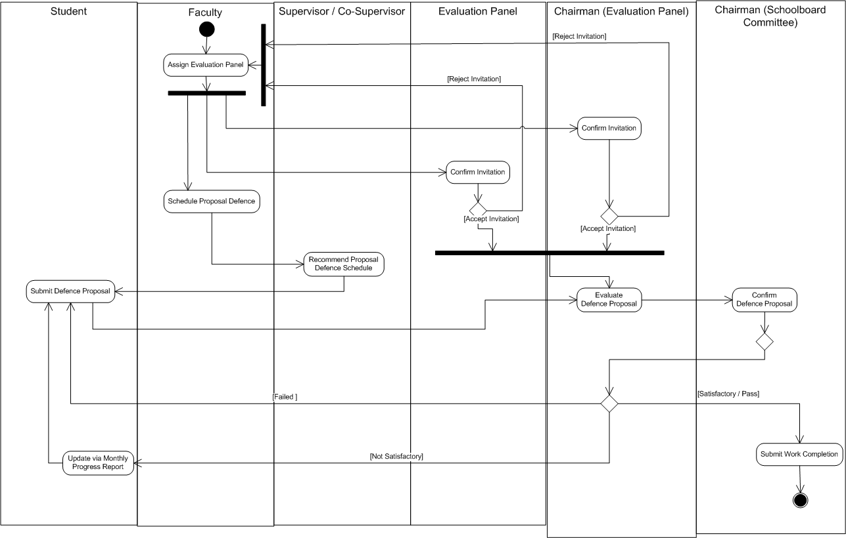

Figure 4: Defence Proposal Submission Process Flow

## Work Completion Process Flow



Figure 5: Work Completion Process Flow

## VIVA Evaluation Process Flow





Figure 6: VIVA Evaluation Process Flow

# 

# MODULE and FEATURE

## Available Module and Feature

The user will have the access to all the modules as listed below:

| **Module** | **Feature** | **Description** |
| --- | --- | --- |
| Main | Announcement | List of announcement published by the Faculty to announce important event or information to the student |
| Thesis | Thesis Profile | Retrieve a list of the postgraduate student which has been submitted the thesis proposal by searching their Thesis ID or Title. |
|  | Student Profile | Retrieve a list of the postgraduate student by searching their student matrix number or name. |
|  | List of Thesis | Retrieve a list of the postgraduate student which the thesis has been approved by the Senate |
| Monthly Progress Report | List Monthly Progress Report | View and monitor the Monthly Progress Report submission by the Student to the Supervisor. |
| Work Completion | Verify Amendment | Verify the amendment done by the Student against the feedback provided by the Evaluation Panel. |
| Thesis Evaluation / VIVA | List of Evaluation Result | View a list of VIVA evaluation result which has been recommended by the Evaluation Panel and agreed by the Schoolboard. |
|  | List of Appeal | View and confirm the appeal request by the Student to re-submit the VIVA |
|  | Amendment Review | Review the amendment completed by the student based on the feedback given by the Evaluation Panel. |
| Administration | Assign Evaluation Panel | Facility to assign Evaluation Panel to the student to evaluate the student Proposal Defence, Work Completion or Viva. |
|  | Schedule Evaluation Session | Facility to set a list of schedule date and venue for student evaluation for Proposal Defence, Work Completion or Viva. |
|  | Reviewer Feedback Approval | View the feedback provided by Reviewer for the student’s thesis proposal.  Approve the request by Reviewer to extend the feedback date to Faculty. |
|  | Unassign Supervisor | Facility to unassign the Supervisor / Co-Supervisor from the student |
|  | Proposal Confirmation | Facility to confirm the thesis proposal status either to approved or disapproved. |
|  | Proposal Cancellation | Facility to approve the cancellation request by the student on submitted thesis proposal. |
|  | Assign Reviewer | Facility to assign the Reviewer to the student |
|  | Assign Supervisor | Facility to assign the Supervisor / Co-Supervisor to the student |
|  | Assign Evaluation Panel | Facility to assign the Evaluation Panel (Chairman, External Examiner, Internal Examiner) to the student |
|  | List of Thesis Proposal | View the list of disapproved thesis proposal |
| Message | Inbox | This feature is the page where the messages are displayed to the student either it is sent by the sender or automatically triggered by the system due to some activity. |
|  | New Message | This feature is the page where the student will create and submit a message to the recipient. |
|  | Sent | This feature is the page where the student can find all the messages which have been sent to the recipient. |
| Control Panel | Change Password | This feature is provided to the student (as a user) to change the password as and when required to comply with the application security requirement |
| HELP | FAQ | This feature is the page where the frequent asked questions are displayed and listed to the student. |
|  | User Manual | This feature is the page where the relevant user manuals in PDF format are made available to the student for reference. |
|  | Online Help | This feature is an alternative help to the user manual. |
|  | About Us | Information page about the system and the team. |

Figure 7: Modules and Features

# MAIN

## Announcement

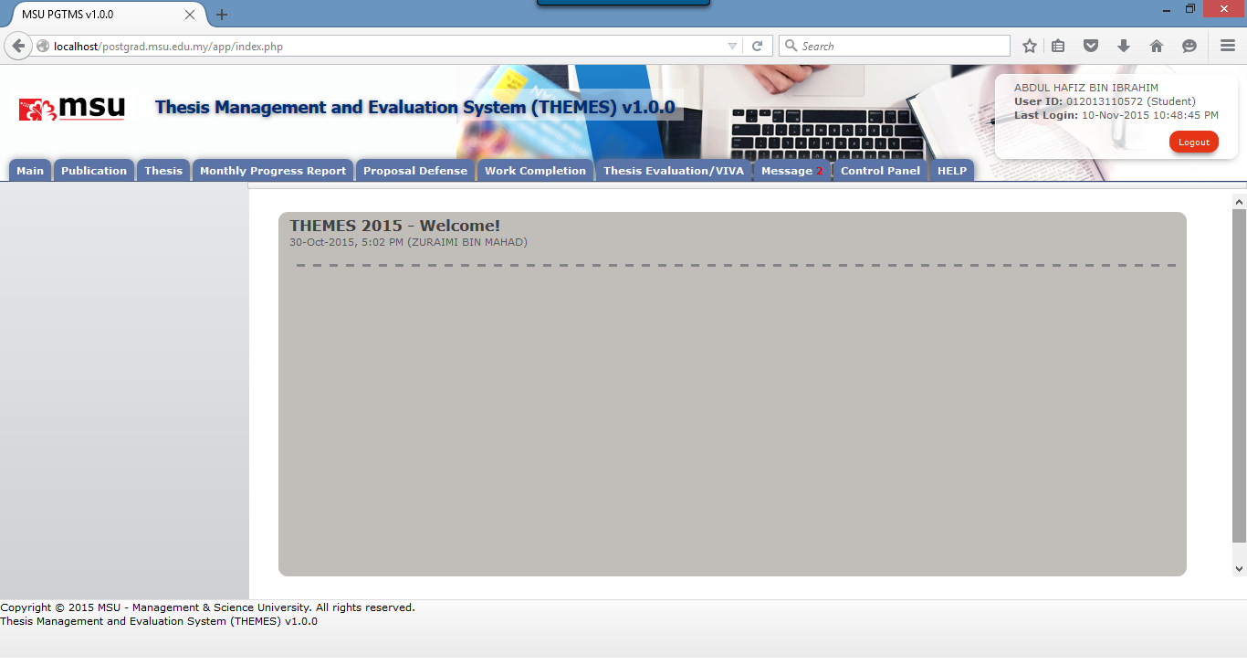

**1**

Figure 8: Announcement

**Prerequisite**

The user has to successfully login to the system first.

**Steps**

Observe the list of announcement as listed on the **Working Area** section

**Warning**

None

**Note**

Note

# LOGIN and LOGOUT

## Login

This is the first page sight by the student to enter the PGTMC system.

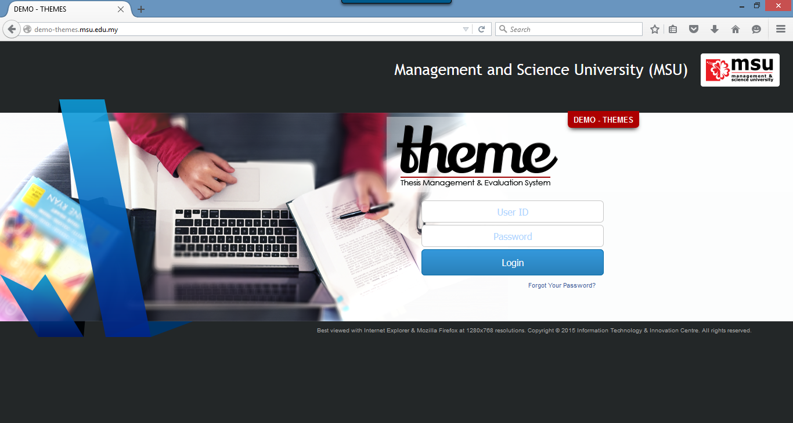

**2**

**1**

Figure 9: Login Page

**Prerequisite**

The user must have the User ID and Password registered with the THEMES system

**Steps**

1. Open the Internet Browser i.e. Mozilla Firefox or Microsoft Internet Explorer

Enter this URL <http://themes.msu.edu.my/> to access the system

1. Login page will be displayed in which the user needs to provide the **User ID** and **Password**.

**Warning**

1. If the provided **User ID** and **Password** are incorrect, the system will prompt an error message and the user needs to provide the right **User ID** and **Password** again.
2. Just in case the user forgot the password, it can be reset via the Forgot Your Password.

**Note**

None

## Logout

Once the necessary or required activities has been done or completed, the student can quit from the system by clicking on the **Logout** button.

If the system is keep idle for about 1 minute, the system will logged out the user automatically.

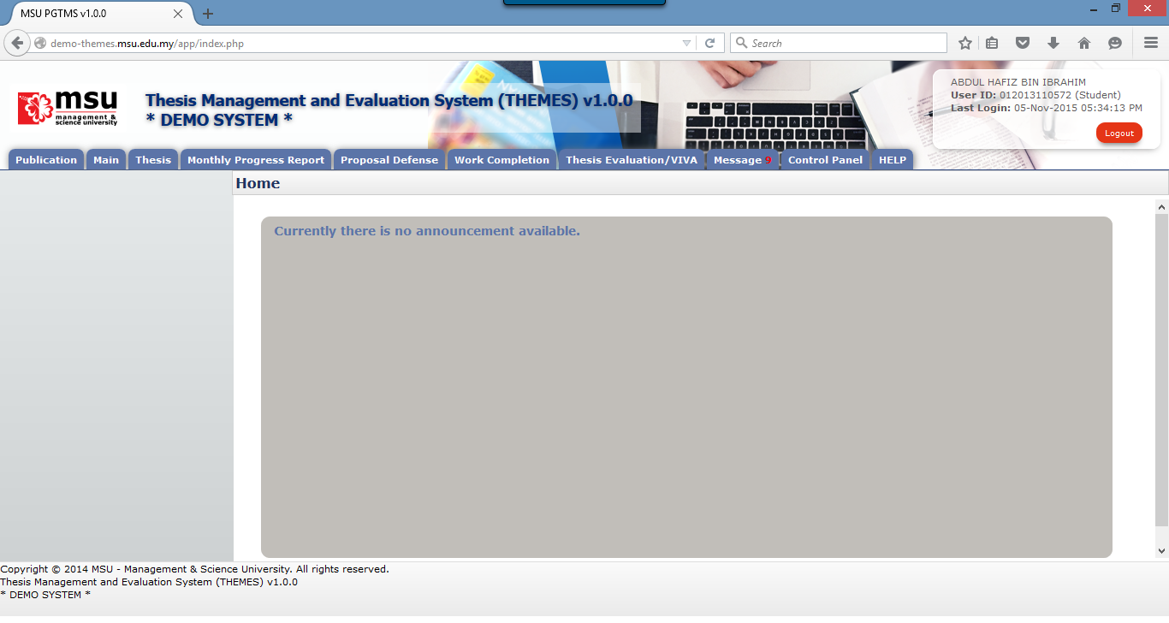

**1**

Figure 10: Logout Page

**Prerequisite**

The user has to successfully login to the system first.

**Step**

Find the **Logout** button located on the right top corner of the system **Header** section. Click on it and you will be logout from the system successfully.

**Warning**

None

**Note**

It is advisable to the user to properly logout from the system instead of force quit by closing the windows.

# THESIS

## List of Thesis

**1**

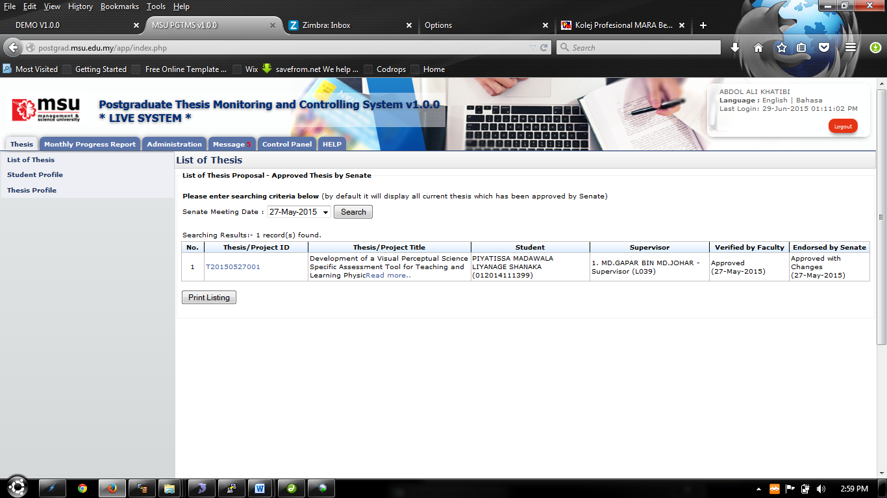

**5**

**3**

**4**

**2**

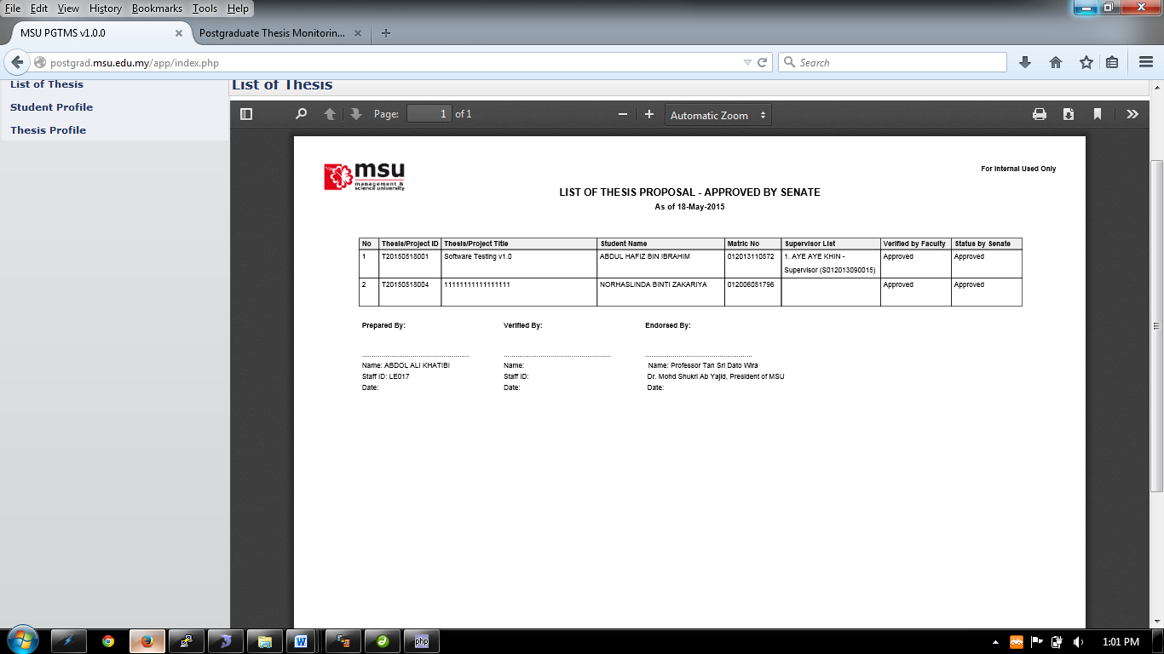

Figure 11: Thesis Tab – List of Thesis

**Pre-condition**

Thesis has been approved by Senate

**Steps**

1. Click on the **Thesis** tab on the system **Top** panel section.
2. The **List of Thesis** menu will be displayed on the system **Left** panel and click on it.
3. The searching page will be displayed which the user can search for a particular thesis that has been approved by the Senate in order to view its detail. Select the **Senate Meeting Date** at the field and click on **Search** button to search the thesis
4. The record will be displayed under the search result.
5. To print the detail, click **Print Listing** button to proceed.

**Next Action**

1. View thesis detail
2. Print listing thesis

**Warning**

None

**Next Action**

None

## Student Profile

View the student details which has the Student Profile, Supervisor/Co-supervisor lists, Subject Taken and Thesis History.

**1**

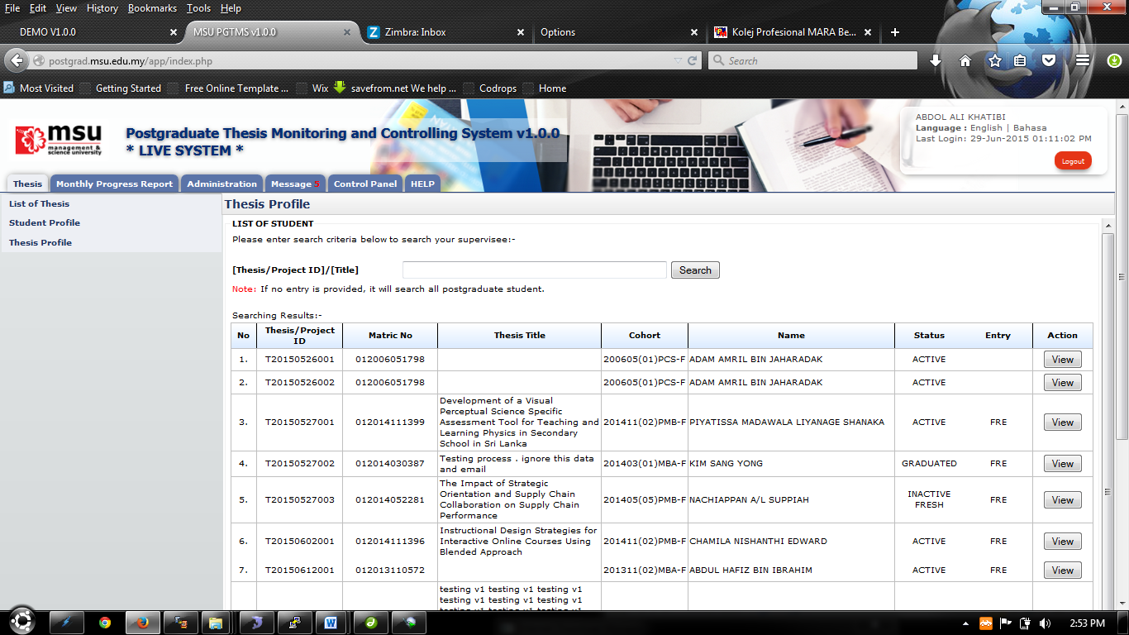

**4**

**3**

**2**

Figure 12: Thesis Tab

**Prerequisite**

All the postgraduate student record has been registered into the system

**Steps**

1. Click on the **Thesis** tab on the system **Top** panel section.
2. The **Student Profile** menu will be displayed on the system **Left** panel and click on it.
3. The searching page will be displayed which the user can search for a particular thesis in order to view its detail. Enter the **Thesis ID** or **Title**. into the field and click on **Search** button to search the thesis
4. The record will be displayed under the search result. Locate the student from the list and click **View** button to view the profile details

**Next Action**

View the Student Profile, Supervisor/Co-supervisor lists, Subject Taken and Thesis History

**Warning**

None

**Note**

None

### Student Profile

Student Profile tab contains the basic student and thesis information including its thesis progress status

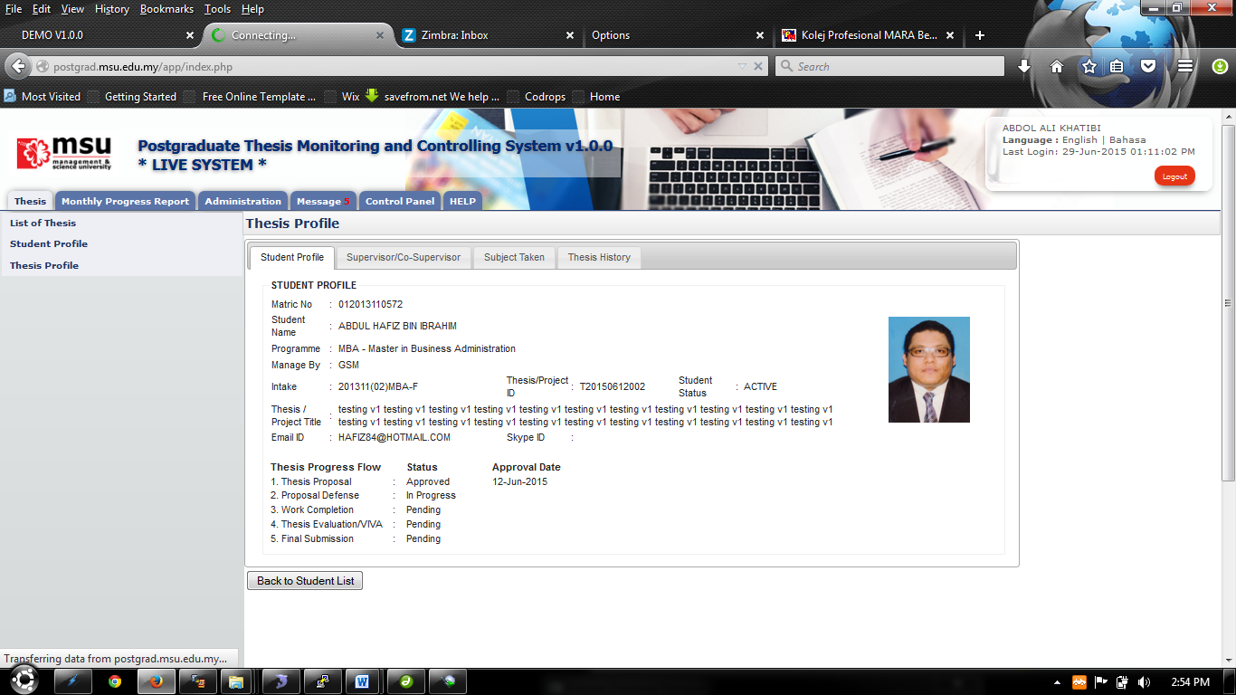

**2**

**1**

Figure 13: Student Profile Tab

**Prerequisite**

The student has been selected

**Steps**

1. View information.
2. Click **Back to Student List** button to return back to **Student List** search page

**Next Action**

None

**Warning**

None

**Note**

None

### Supervisor/Co-Supervisor List

Supervisor or Co-Supervisor is the academic staff who has been assigned by Faculty to supervise the student in delivering the thesis and approved by the Senate.

There are conditions for the student to see the list of his/her supervisors. The conditions are:-

1. Supervisor/Co-Supervisor has been assigned by Faculty and approved by the Senate
2. Supervisor/Co-Supervisor has accepted the appointment to supervise the student.

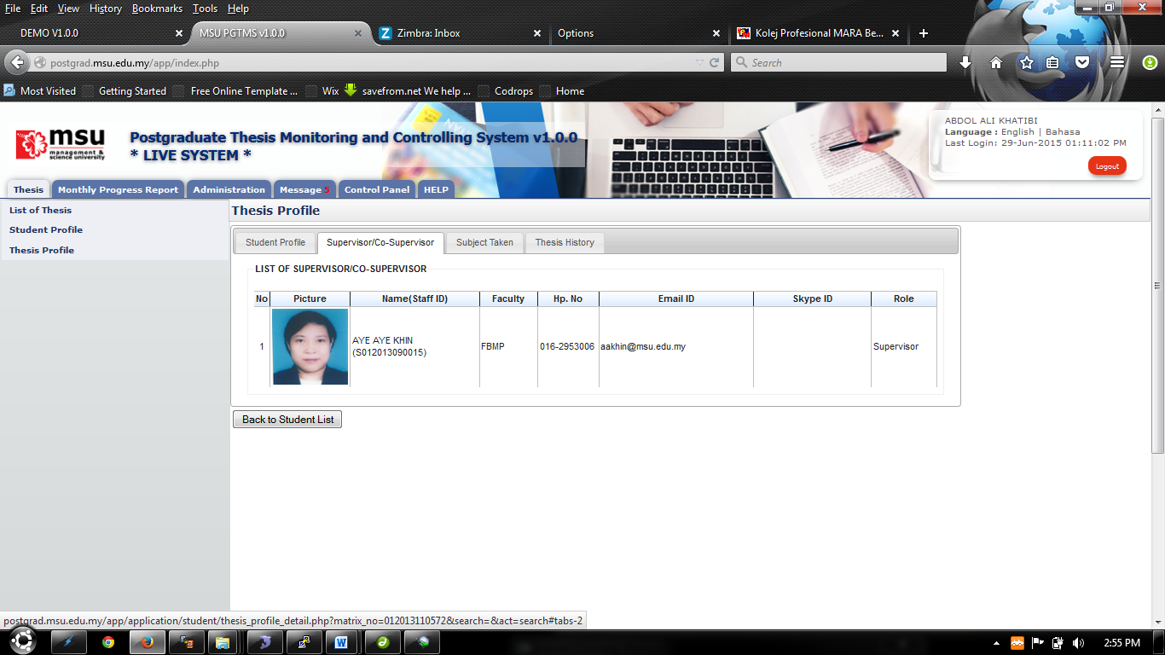

**2**

**1**

Figure 14: List of Supervisor / Co-Supervisor

**Prerequisite**

The student has been selected

**Steps**

1. View information.
2. Click **Back to Student List** button to return back to **Student List** search page

**Next Action**

None

**Warning**

None

**Note**

None

### Subject Taken

Subject Taken tab will list the entire subject registered by the students for all semester during his study.

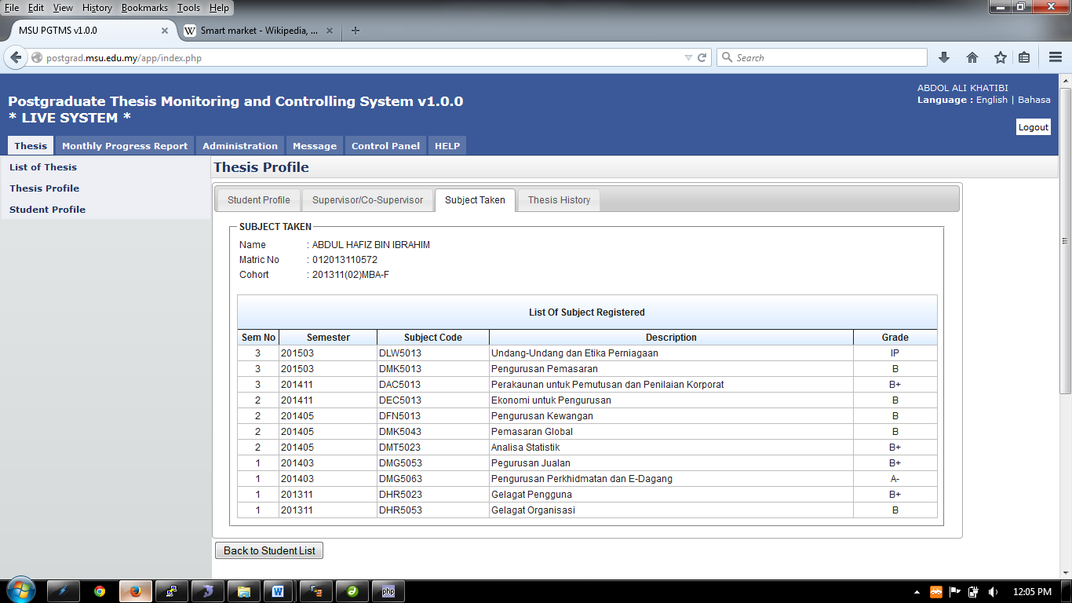

**1**

**2**

Figure 15: Subject Taken

**Prerequisite**

The student has been selected

**Steps**

1. View information.
2. Click **Back to Student List** button to return back to **Student List** search page

**Next Action**

None

**Warning**

None

**Note**

None

### Thesis History

Thesis History tab contains the proposal progress history starting from its submission by the student until its approval by the Senate. It captures the date of

****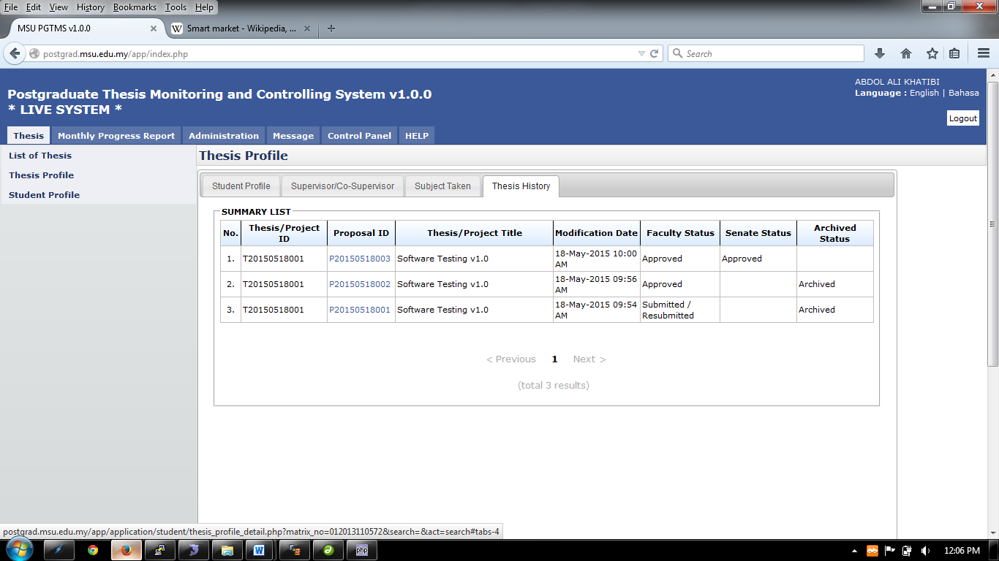

**1**

**2**

Figure 16: Thesis Tab – Thesis History

**Prerequisite**

The student has been selected

**Steps**

1. View information.
2. Click **Back to Student List** button to return back to **Student List** search page

**Next Action**

None

**Warning**

None

**Note**

None

## Thesis Profile

Thesis profile can be retrieved via student’s **Name** or **Matrix Number**.

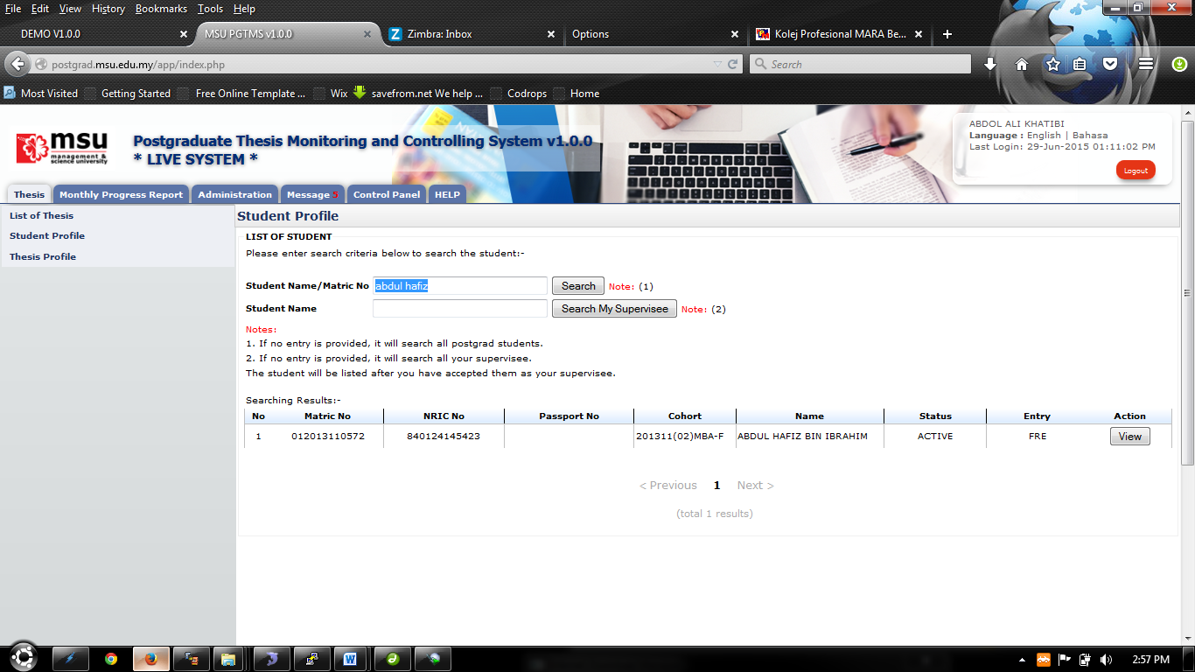

**1**

**4**

**3**

**2**

Figure 17: Thesis Tab – List of Student

**Prerequisite**

All the postgraduate student record has been registered into the system

**Steps**

1. Click on the **Thesis** tab on the system **Top** panel section.
2. The **Student Profile** menu will be displayed on the system **Left** panel and click on it.
3. The searching page will be displayed which the user can search for a particular student in order to view its detail. Enter the **Student’s Name** or **Matrix No**. into the field and click on **Search** button to search the student.
4. The record will be displayed under the search result. Locate the student from the list and click **View** button to view the profile details

**Next Action**

View the Student Profile, Supervisor/Co-supervisor lists, Subject Taken and Thesis History

**Warning**

None

**Note**

None

### Student Profile Details

View the student details which has the Student Profile, Supervisor/Co-supervisor lists, Subject Taken and Thesis History.



**2**

**1**

Figure 18: Thesis Tab – Student Profile

**Prerequisite**

The student has been selected

**Steps**

1. View information.
2. Click **Back to Student List** button to return back to **Student List** search page

**Next Action**

None

**Warning**

None

**Note**

None

### Supervisor/Co-Supervisor List

Supervisor or Co-Supervisor is the academic staff who has been assigned by Faculty to supervise the student in delivering the thesis and approved by the Senate.

There are conditions for the student to see the list of his/her supervisors. The conditions are:-

1. Supervisor/Co-Supervisor has been assigned by Faculty and approved by the Senate
2. Supervisor/Co-Supervisor has accepted the appointment to supervise the student.



**1**

**2**

Figure 19: Thesis Tab - List of Supervisor / Co-Supervisor

**Prerequisite**

The student has been selected

**Steps**

1. View information.
2. Click **Back to Student List** button to return back to **Student List** search page

**Next Action**

None

**Warning**

None

**Note**

None

### Subject Taken

Subject Taken tab will list the entire subject registered by the students for all semester during his study.



**2**

**1**

Figure 20: Thesis Tab - Subject Taken

**Prerequisite**

The student has been selected

**Steps**

1. View information.
2. Click **Back to Student List** button to return back to **Student List** search page

**Next Action**

None

**Warning**

None

**Note**

None

### Thesis History

Thesis History tab contains the proposal progress history starting from its submission by the student till its approval by the Senate. It captures the date of

****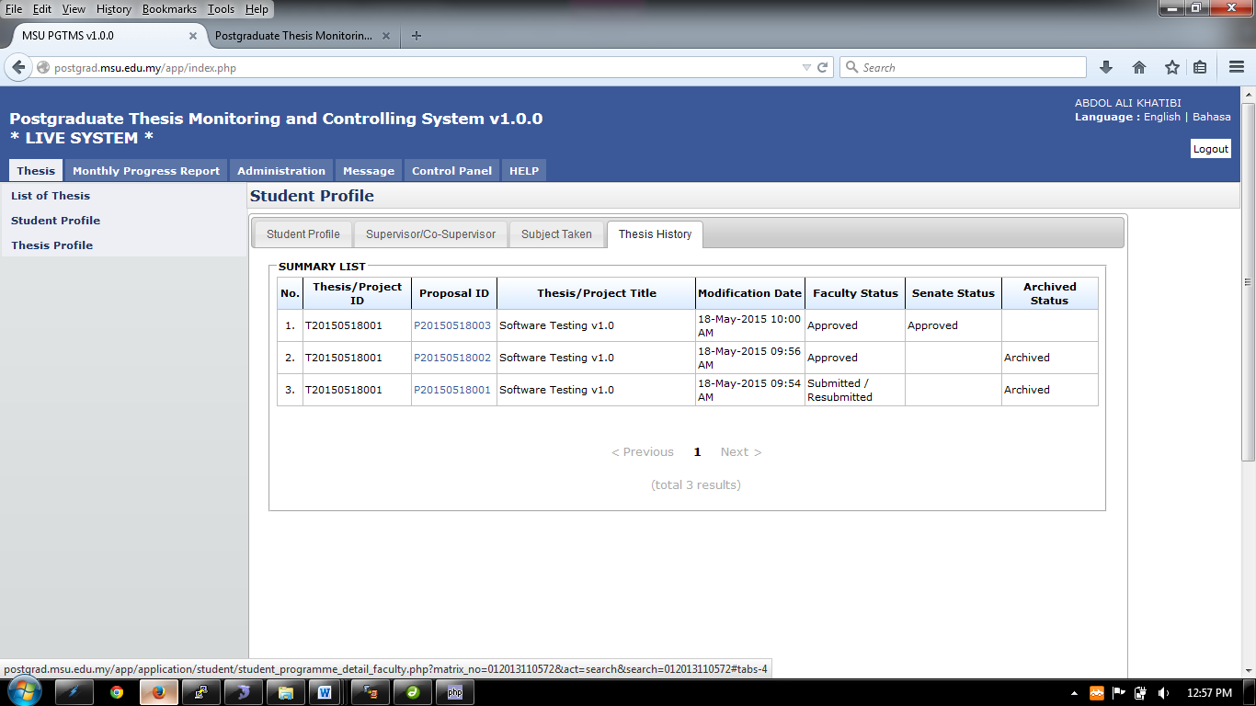

**1**

**2**

Figure 21: Thesis Tab – Thesis History

**Prerequisite**

The student has been selected

**Steps**

1. View information.
2. Click **Back to Student List** button to return back to **Student List** search page

**Next Action**

None

**Warning**

None

**Note**

None

# MONTHLY PROGRESS REPORT

The Faculty User to view the status of the monthly progress report for each of the student.

## List Monthly Progress Report

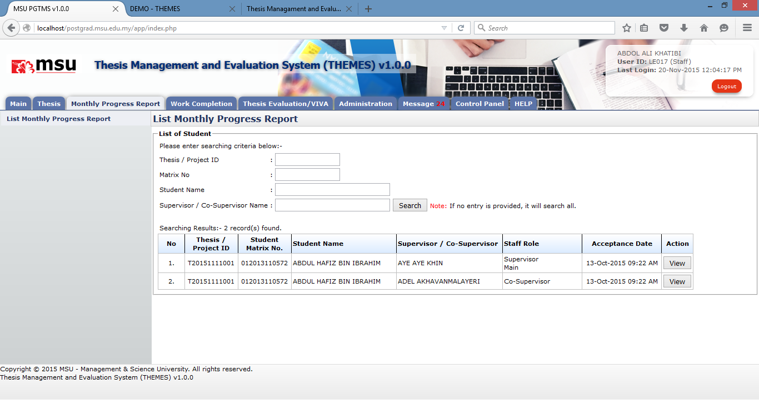

**3**

**4**

**2**

**1**

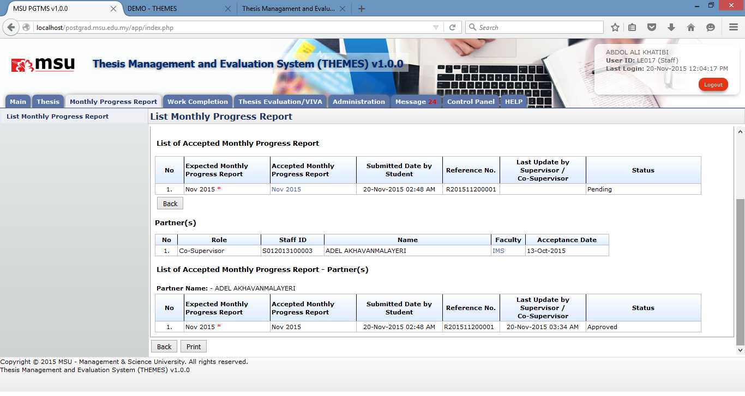

**5**

Figure 22: List Monthly Progress Report

**Prerequisite**

The Supervisor has accepted the invitation

The Student has submitted the Monthly Progress Report

**Steps**

1. Click on the **Monthly Progress Report** tab at the **Top Panel** section
2. Click on the **List Monthly Progress Report** link at the **Left Panel** section
3. The **List of Student** page will be displayed at the **Working Area** section. Enter the search criteria if to find specific result or otherwise just click the **Search** button to get general result.
4. The result will be displayed on the searching result table. Locate the student and click **View** button to view the detail.
5. Click **Print** button if to generate printable view format.
6. Click **Back to Student List** button to return back to **Student List** search page

**Next Action**

None

**Warning**

None

**Note**

None

# WORK COMPLETION

The Faculty User to verify the amendment done by the Student based on feedback given by the Examiner.

## Verify Amendment

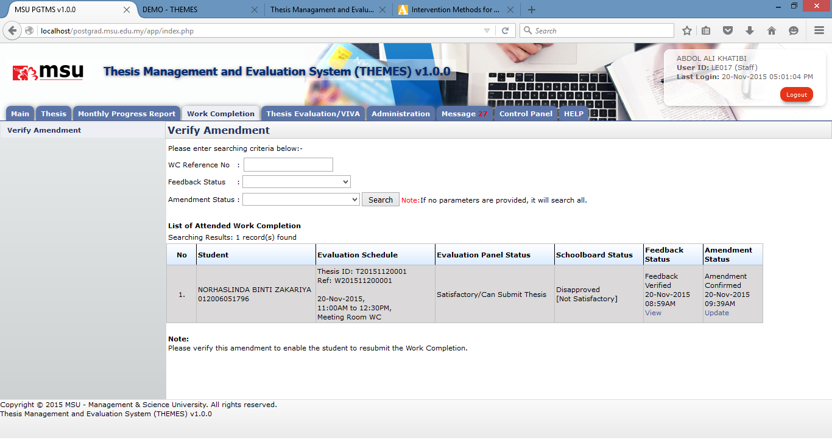

**4**

**3**

**1**

**2**

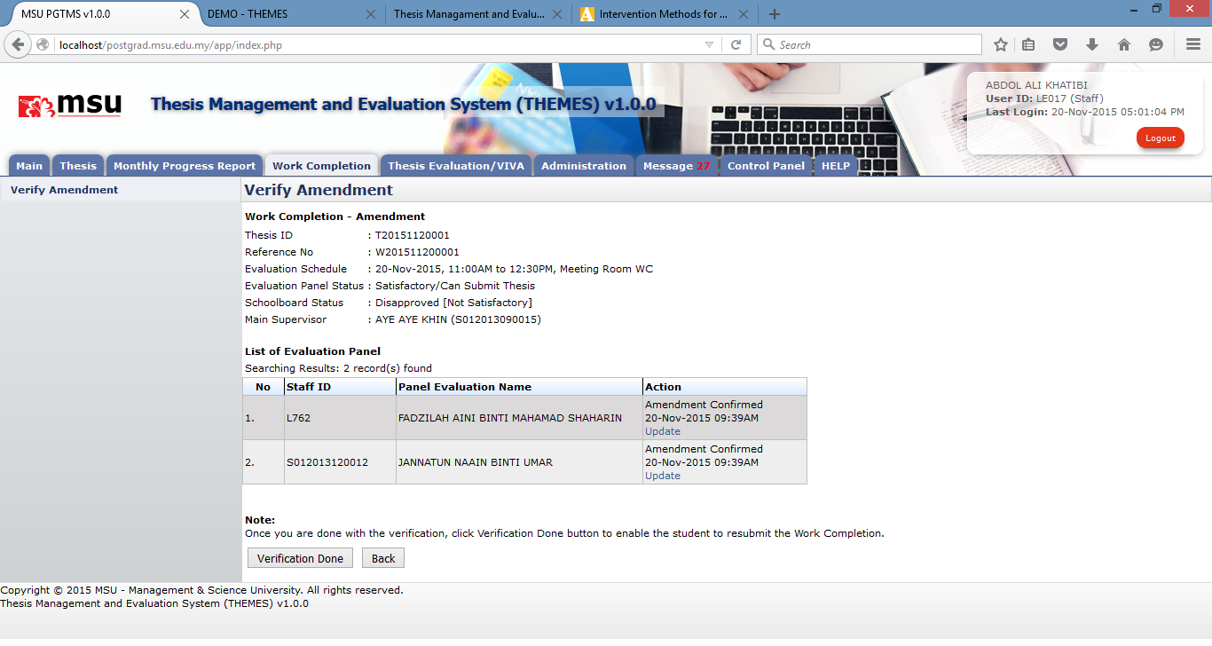

**9**

**5**

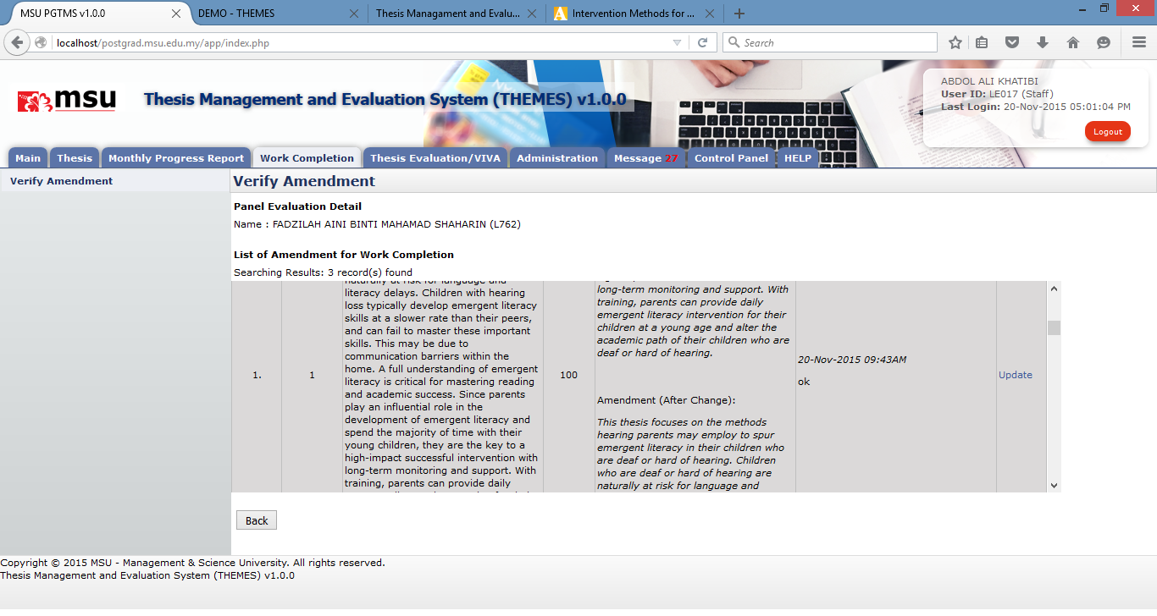

**6**

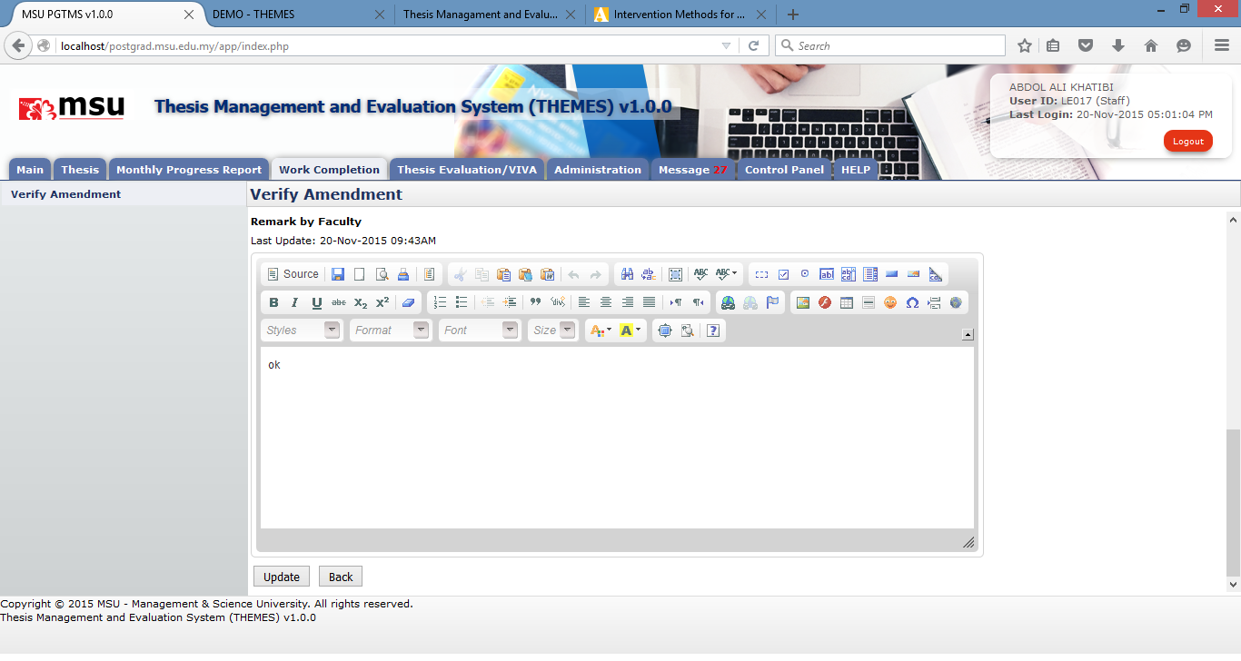

**8**

**7**

Figure 23: Verify Amendment

**Prerequisite**

The Student has submitted the work completion amendment

The Supervisor has verified the work completion amendment

**Steps**

1. Click on the **Work Completion** tab at the **Top Panel** section
2. Click on the **Verify Amendment** link at the **Left Panel** section
3. The following page will be displayed at the **Working Area** section. Enter the search criteria if to find specific result or otherwise just click the **Search** button to get general result.
4. The result will be displayed on the searching result table. Locate the student and click **Update** button to view the detail.
5. The following page will be displayed. Select which student to view and click **Update** button to open the next page if to provide the update.
6. On the page find which amendment item to update, click **Update** button to get the update page.
7. Enter the update detail.
8. Click **Update** button once done. Click Back button to go back to the previous page.
9. Click **Verification** **Done** button if the verification of the amendment is all done.

**Next Action**

None

**Warning**

None

**Note**

None

# THESIS EVALUATION / VIVA

## Amendment Review

The

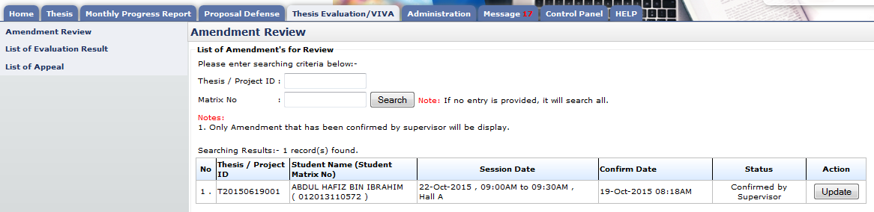

**3**

**2**

**1**

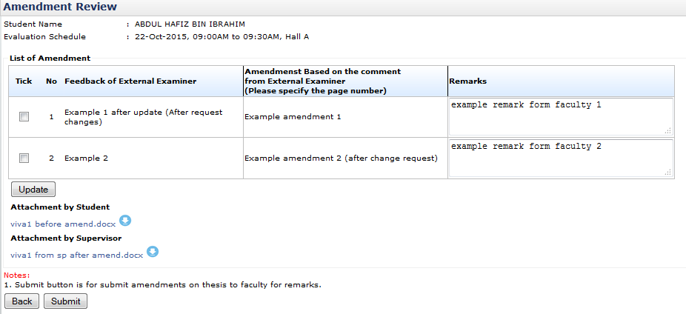

**8**

**7**

**6**

**5**

**4**

Figure 24: Amendment Review

**Prerequisite**

Supervisor must verified amendment first

**Steps**

1. Click on the **Thesis Evaluation/VIVA** tab on the **Top** panel
2. Click on the **Review Amendment On Thesis** menu on the **Left** panel
3. System will display list of amendment. Click on **Update** button.
4. The next following page will be displayed. Enter remark into **Remarks** text field provided.
5. Then tick the checkbox
6. Click **Update** button to save the update.
7. Click on link if to download and view the attachment uploaded by the Student or the Supervisor.
8. Click **Submit** button once the amendment has been reviewed fully and submit it back to the Student

**Next Action**

Student to resubmit the thesis if no fails. If it is failed then the student need to resubmit the thesis to the faculty for re-viva.

**Warning**

None

**Note**

None

## List of Appeal

List of student who has been given a chance to appeal request by the Schoolboard due to thesis’s recommendation result failed in viva. Faculty will either approve or disapprove the request.

**1**

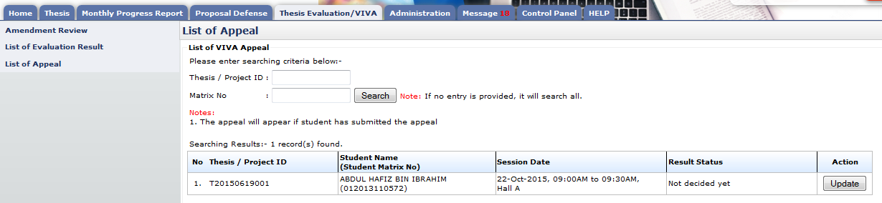

**3**

**2**

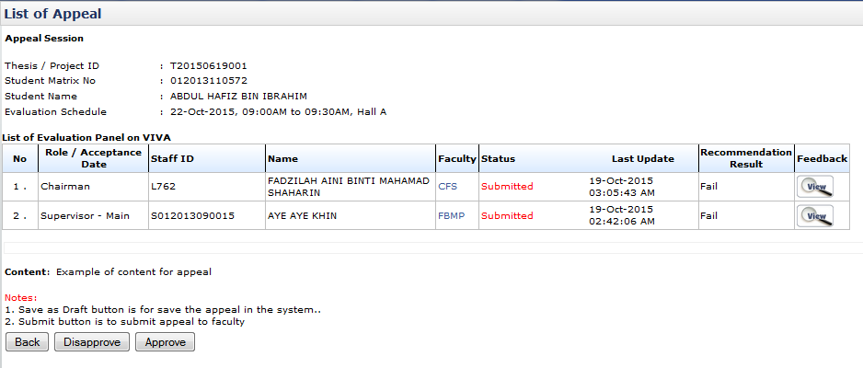

**6**

**4**

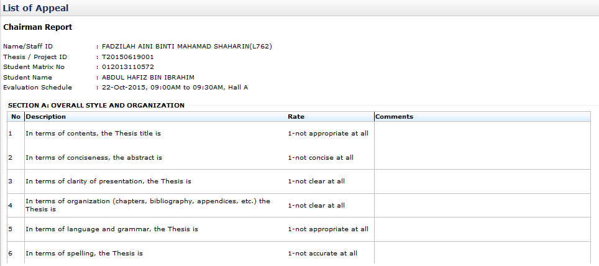

**5**

Figure 25: Appeal Request

**Prerequisite**

Student has submitted the request for appeal.

**Steps**

1. Click on the **Thesis Evaluation/VIVA** tab on the **Top** panel
2. Click on the **List of Appeal** menu on the **Left** panel
3. System will display list of student. Click **Update** button to open next following page.
4. Click **View** icon to view evaluation report of each evaluation panel.
5. The following page will be displayed to display the detail
6. Click **Approve** button to approve OR **Disapprove** button to disapprove the appeal request.

**Next Action**

The Faculty is to approve or disapprove the appeal requested by the Student.

**Warning**

None

**Note**

None

## List of Amendment Result

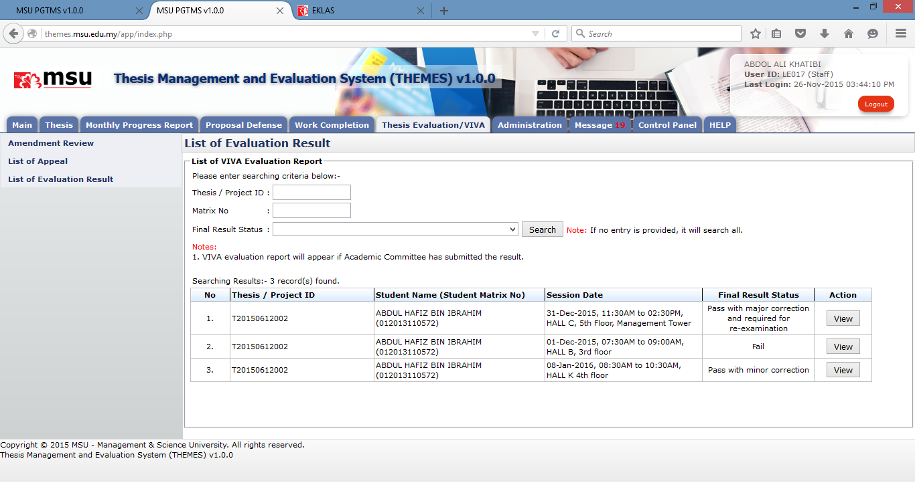

**4**

**5**

**3**

**2**

**1**

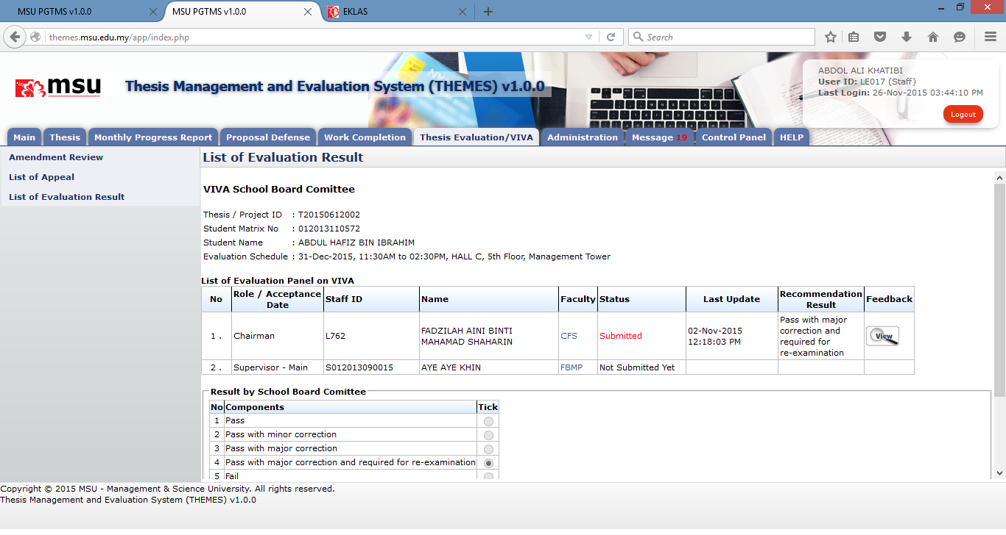

**6**

Figure 26: List of Amendment Result

**Prerequisite**

The Schoolboard has agreed with the recommended VIVA result by the Evaluation Panel.

**Steps**

1. Click on the **Thesis Evaluation/VIVA** tab at the **Top Panel** section.
2. Click on the **List of Evaluation Result** menu at the **Left** **Panel** section.
3. The list of **List of Evaluation Report** will be displayed on the **Working Area** section. Enter the searching criteria if to search specific result or just click the **Search** button to search the general result.
4. The result will be displayed on the **Searching Result** list. Observe the **Final Result Status** for each of the student’s VIVA.
5. Find the student you wanted to view the detail and click on the **View** button.
6. The next following page will be displayed which show the detail of the student’s VIVA result.

**Next Action**

The Senate to acknowledge the student’s VIVA result recommended by the Schoolboard.

**Warning**

None

**Note**

None

# ADMINISTRATION

## Assign Evaluation Panel

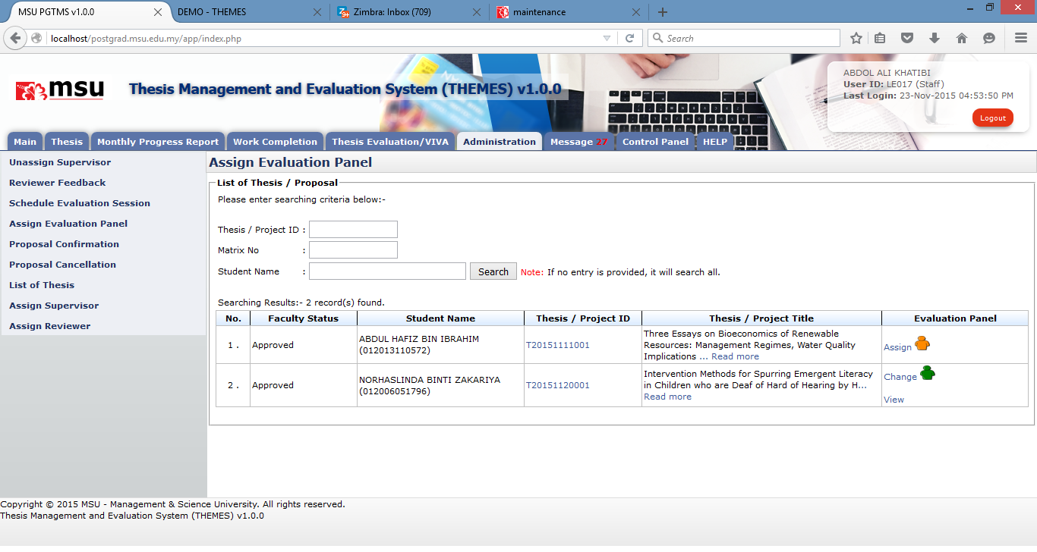

**3**

**2**

**1**

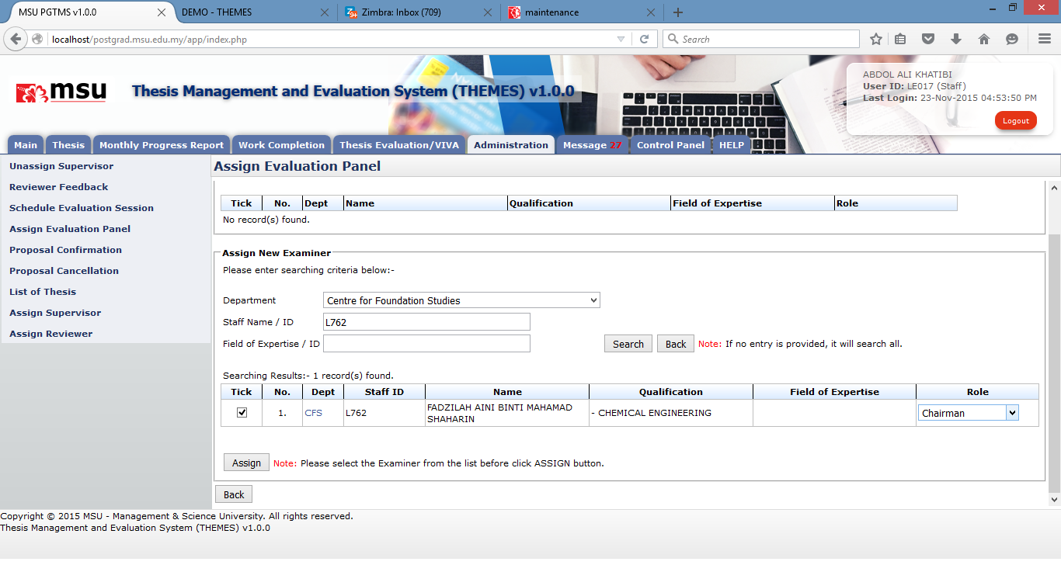

**5**

**7**

**6**

**4**

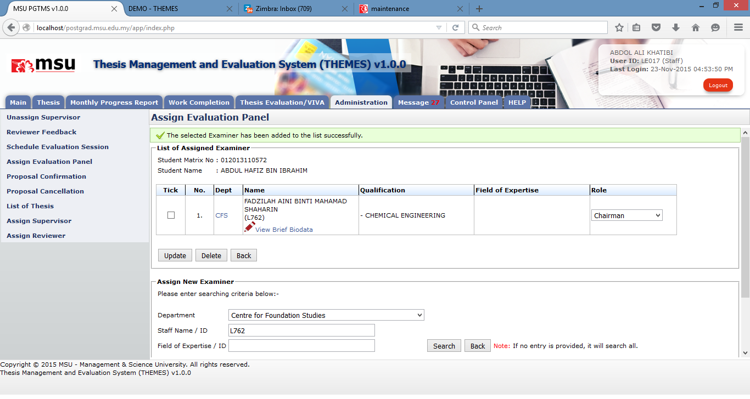

**11**

**12**

**10**

**9**

**8**

Figure 27: Assign Evaluation Panel

**Prerequisite**

The student has submitted the defence proposal

**Steps**

1. Click on the **Administration** tab at the **Top Panel** section.
2. Click on the Assign Evaluation Panel menu at the **Left** **Panel** section.
3. The list of Thesis Proposal is displayed on the **Working Area** section. Click on the **Assign** link.
4. The next following page will be displayed. Enter the searching criteria if to search specific result or just click the Search button to search the general result.
5. The result will be displayed on the list. Tick the checkbox for the staff being identified to be the panel.
6. Select the role.
7. Then click the **Assign** button to assign the staff for the selected role to the student.
8. The staff will be listed in the List of Assigned Examiner table.
9. If you want to delete the selected staff, tick the respective checkbox.
10. Then click the **Delete** button to remove the staff from the list.
11. If you want to update the role, change the role.
12. Then click the Update button to save the change.

**Next Action**

The Evaluation panel is to accept the invitation.

**Warning**

None

**Note**

None

## Schedule Evaluation Session

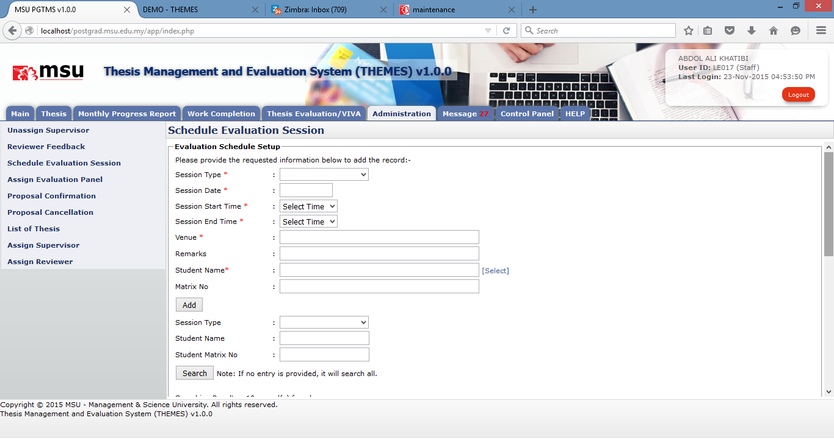

**3**

**4**

**2**

**1**

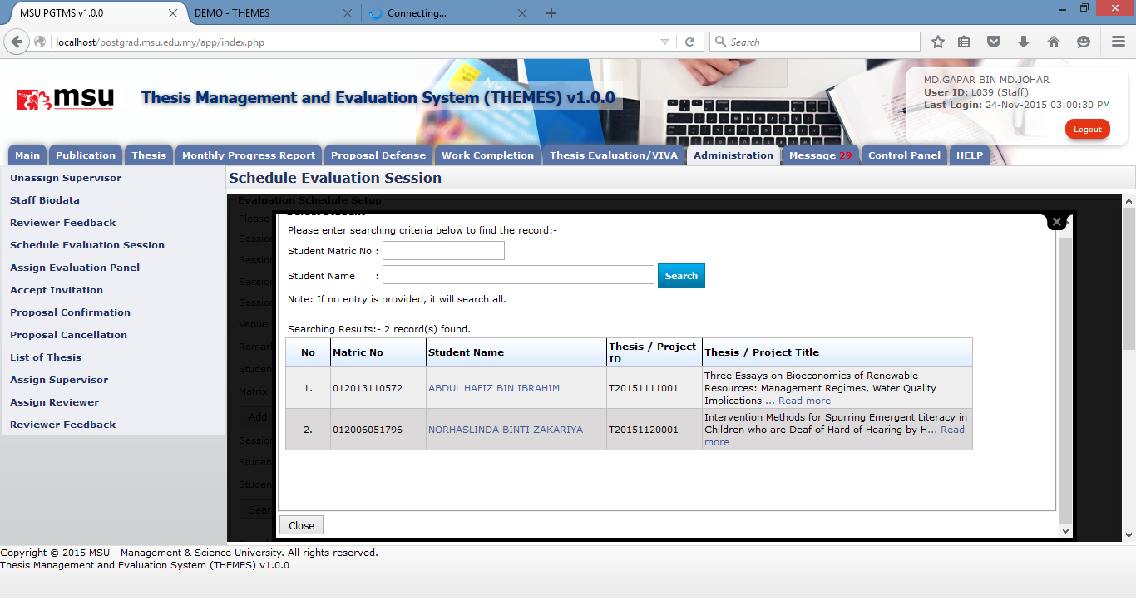

**6**

**5**

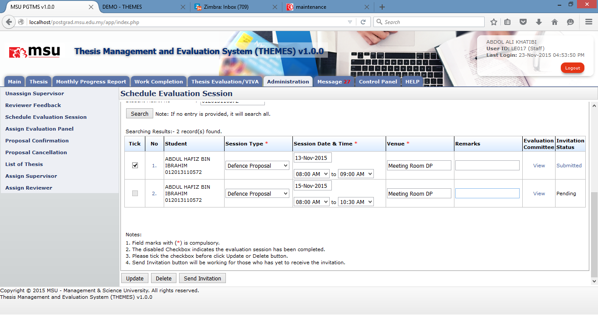

**12**

**11**

**10**

**9**

**7**

**8**

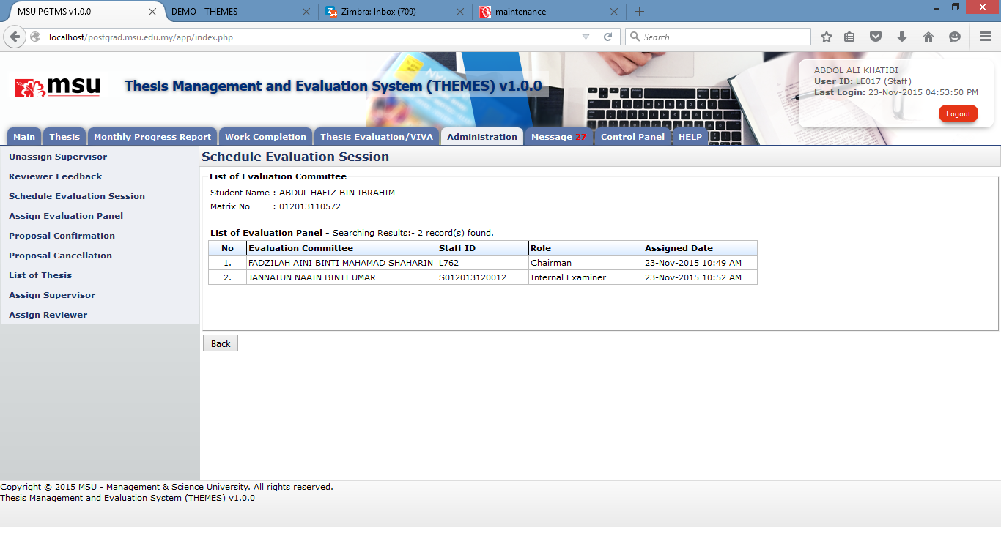

**13**

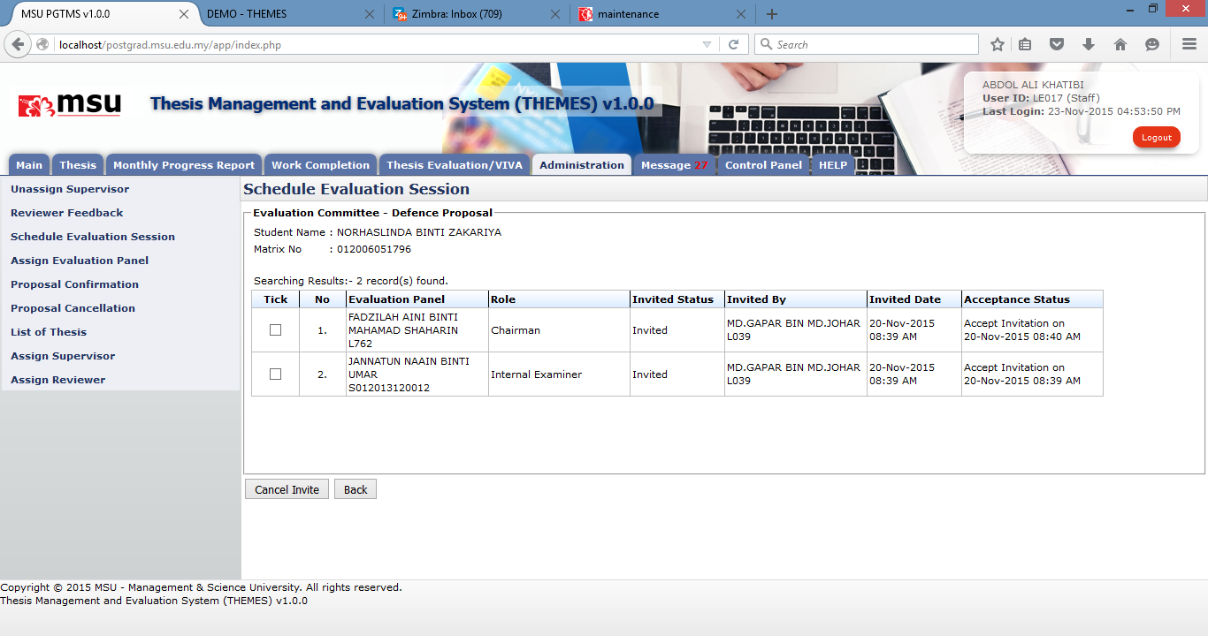

**16**

**15**

**14**

Figure 28: Schedule Evaluation Session

**Prerequisite**

The student has submitted the Defence Proposal, Work Completion or VIVA.

**Steps**

1. Click on the **Administration** tab at the **Top Panel** section.
2. Click on the **Schedule Evaluation Session** menu at the **Left** **Panel** section.
3. The Evaluation Schedule Setup Page is displayed on the **Working Area** section. Enter the information required.
4. Click on the **Select** link to select the student.
5. The next following page will be displayed. Enter the searching criteria if to search specific result or just click the Search button to search the general result.
6. The result will be displayed on the list. Click on the student name.
7. The selected student will be populated on the previous page.
8. If you want to delete the selected staff, tick the respective checkbox.
9. Then click the **Delete** button to remove the staff from the list.
10. If you want to update the **Session Type, Date and Time, Venue** or **Remark**, change it on the respective fields. Tick the checkbox and click on the **Update** button to save the changes.
11. If to view the list of evaluation panel which has been assigned, click on the **View** button.
12. If to view the list of evaluation panel which has been accepted the invitation, click on the **Submitted** button.
13. This is the list of evaluation panel which has been assigned as evaluation panel.
14. This is the list of evaluation panel which has been accepted the invitation.
15. If to cancel the invitation for the invited panel, tick on the checkbox. It can be selected in multiple rows.
16. Then click on the **Cancel** Invite button to confirm the cancellation.

**Next Action**

The Supervisor can recommend the date to the student for the evaluation session.

**Warning**

None

**Note**

None

## Reviewer Feedback Approval

### Feedback by Reviewer

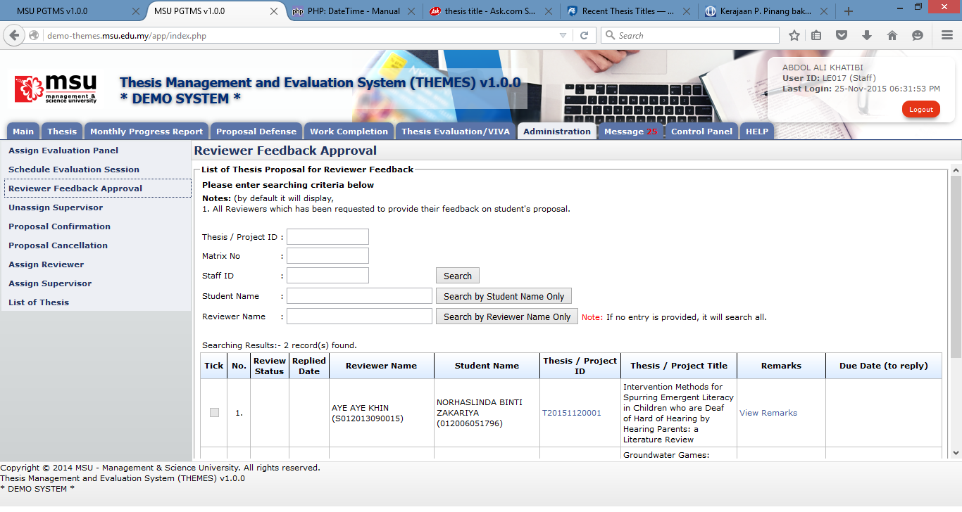

**4**

**3**

**2**

**1**

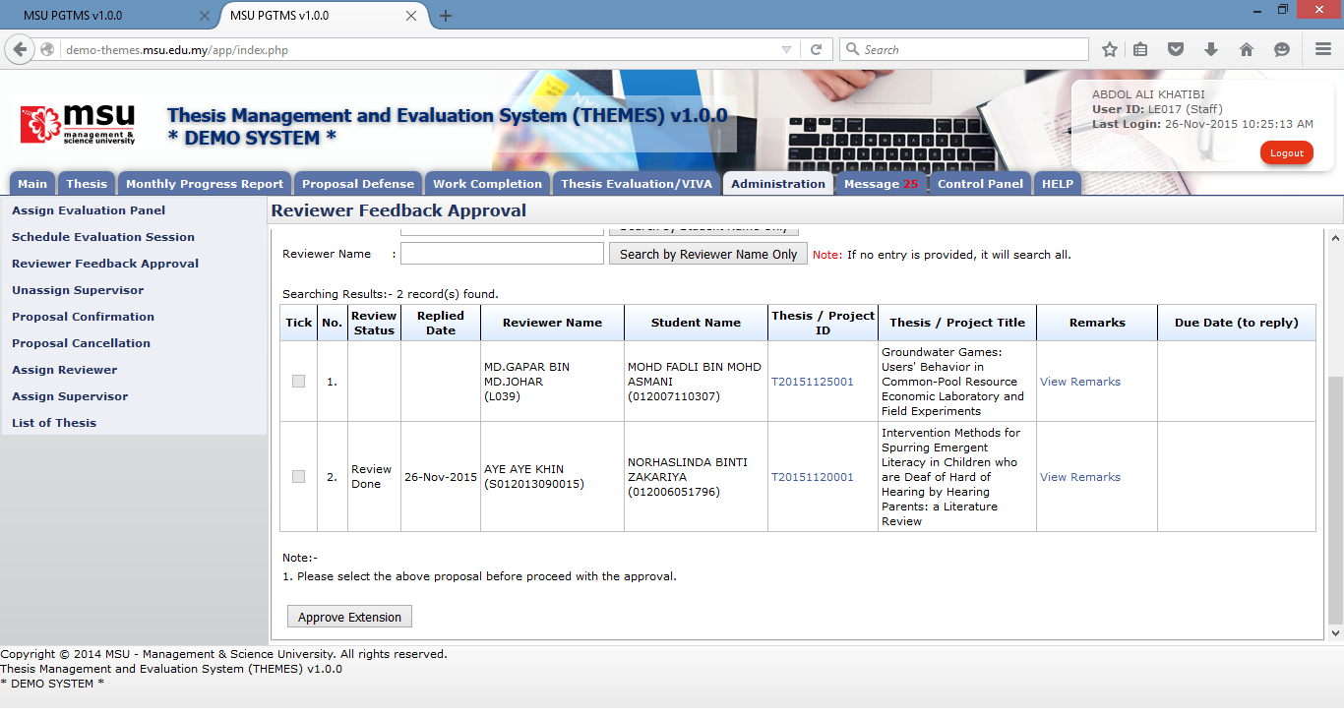

**6**

**5**

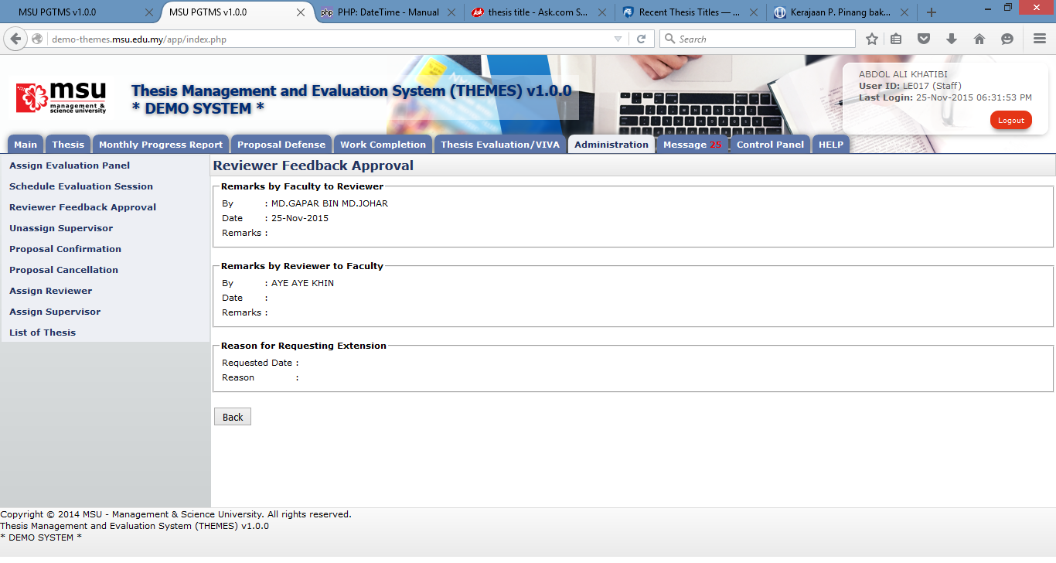

**7**

Figure 29: Administration Tab – Reviewer Feedback Approval

**Prerequisite**

The Faculty has assigned the Reviewer to review the thesis proposal

**Steps**

1. Click on the **Administration** tab at the **Top Panel** section.
2. Click on the **Reviewer Feedback Approval** at the **Left Panel** section.
3. Enter the searching criteria if to find the specific result or just click any search buttons to get the general result.
4. The list of Reviewer will be displayed on the **Working Area** section.
5. If the **Review Status** and **Replied Date** columns are empty, that’s mean the review is still in progress by the Reviewer.
6. Click on the **View Remarks** link if to view the remarks given by the Faculty or Reviewer (if any).
7. The next page will be displayed and show the details.

**Next Action**

None

**Warning**

None

**Note**

None

### Feedback Due – Request Extension Approval

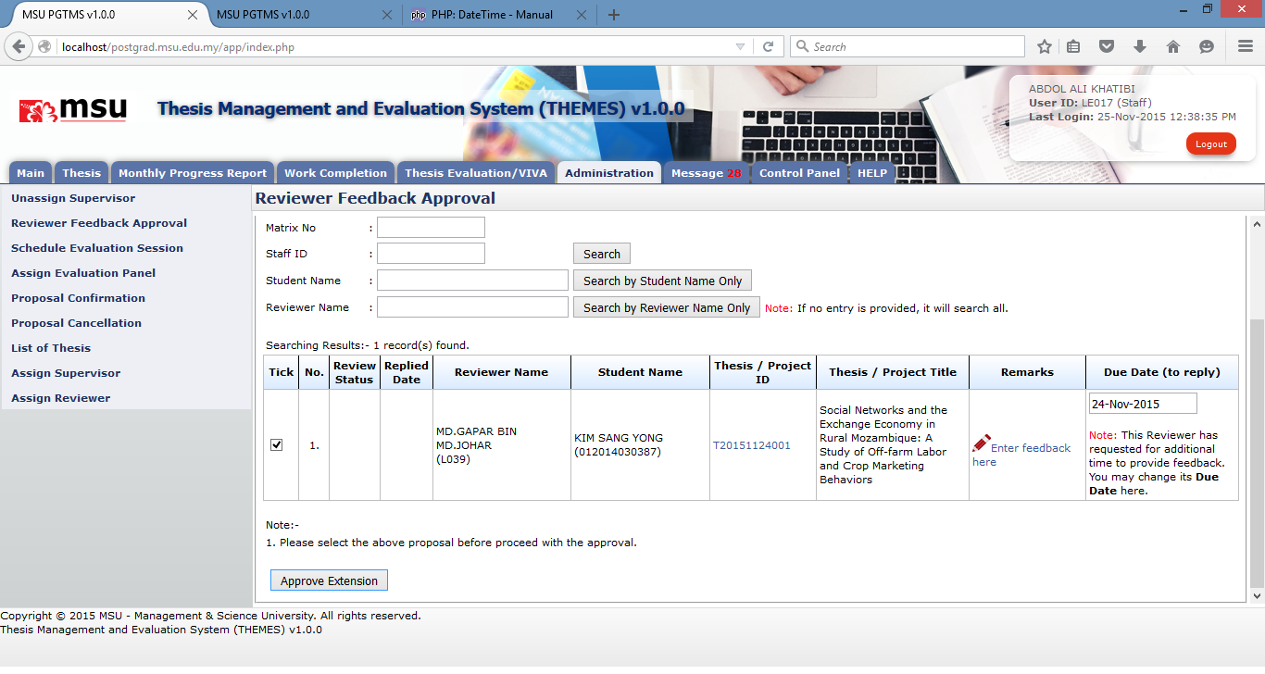

**4**

**5**

**4**

**3**

**2**

**1**

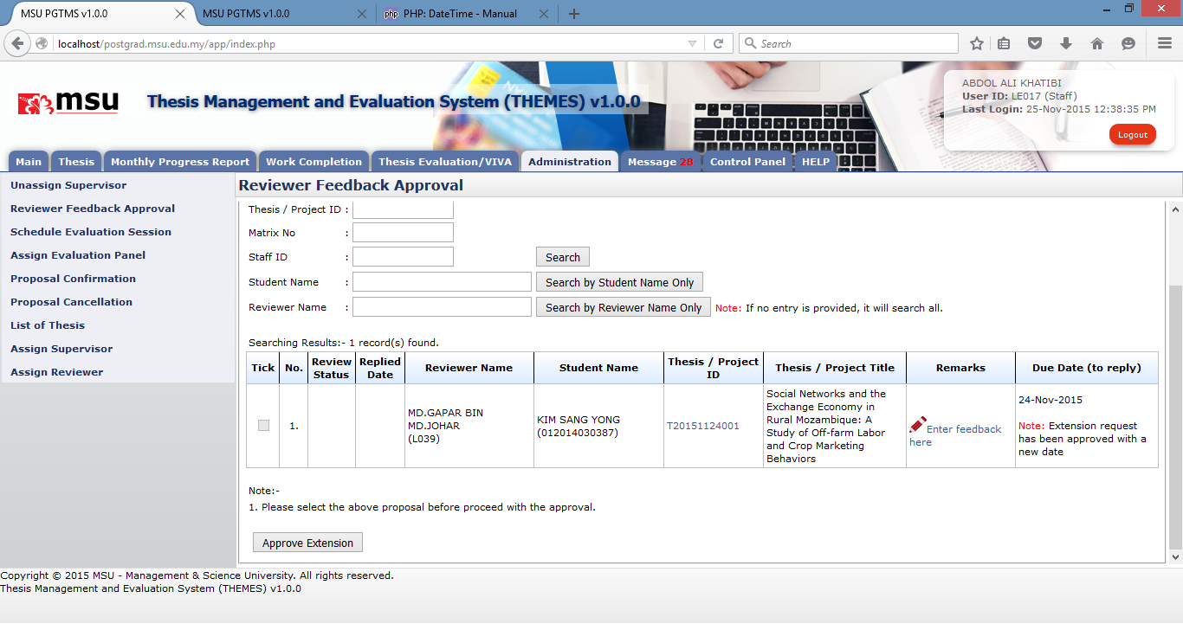

**6**

**6**

Figure 30: Feedback Extension Approval

**Prerequisite**

The Faculty has assigned the Reviewer to review the thesis proposal

**Steps**

1. Click on the **Administration** tab at the **Top Panel** section.
2. Click on the **Reviewer Feedback Approval** at the **Left Panel** section.
3. Enter the searching criteria if to find the specific result or just click any search buttons to get the general result.
4. The list of Reviewer will be displayed on the **Working Area** section. The notice will be displayed showing the request by the Review to extend the review date. By default the system will set the new Due Date. The Faculty User may change it if it is needed. Tick the checkbox to proceed with the approval.
5. Click on the **Approve Extension** to approve the request.
6. The checkbox will be disabled and the message show approval successful will be dispalyed.

**Next Action**

The Reviewer will review the thesis proposal and provide the feedback.

**Warning**

System will prompt a notification message if the checkbox is untick before the submission to approve the extension request.

**Note**

None

## Unassign Supervisor

This facility is provided to the Faculty user if there is a need to unassig the Supervisor from the student due to some reason.

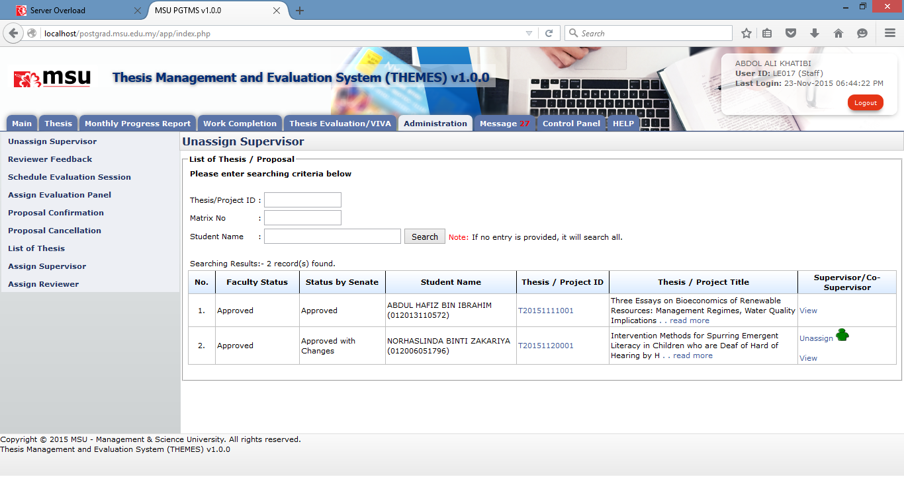

**4**

**3**

**2**

**1**

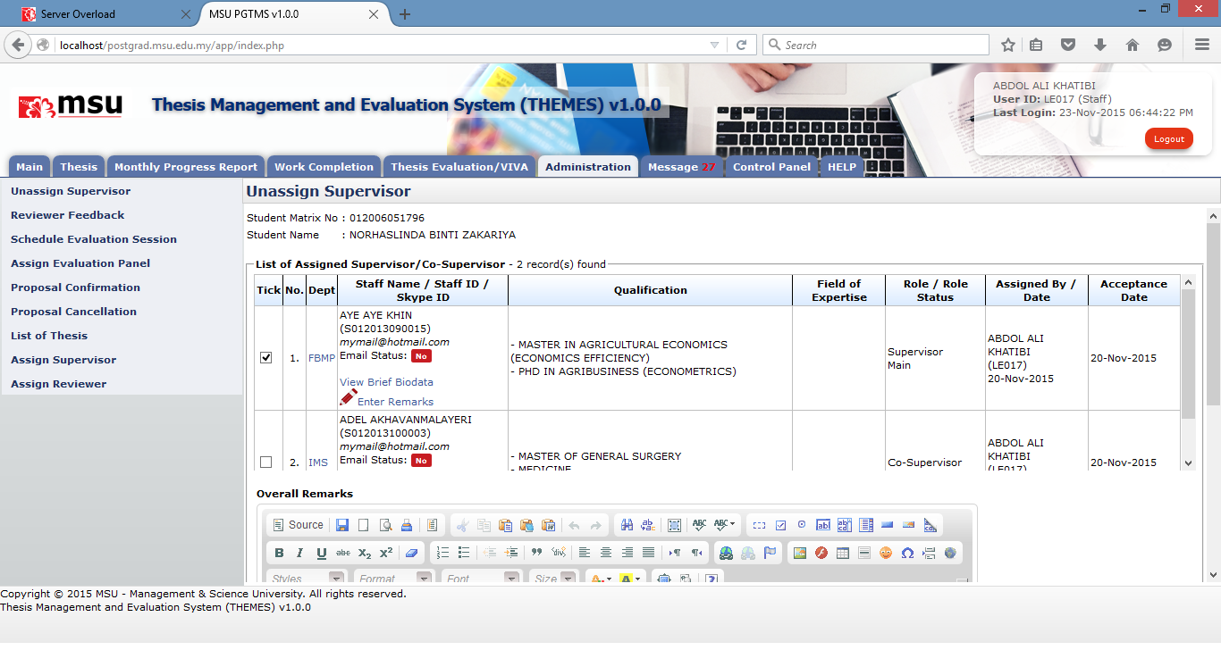

**5**

**6**

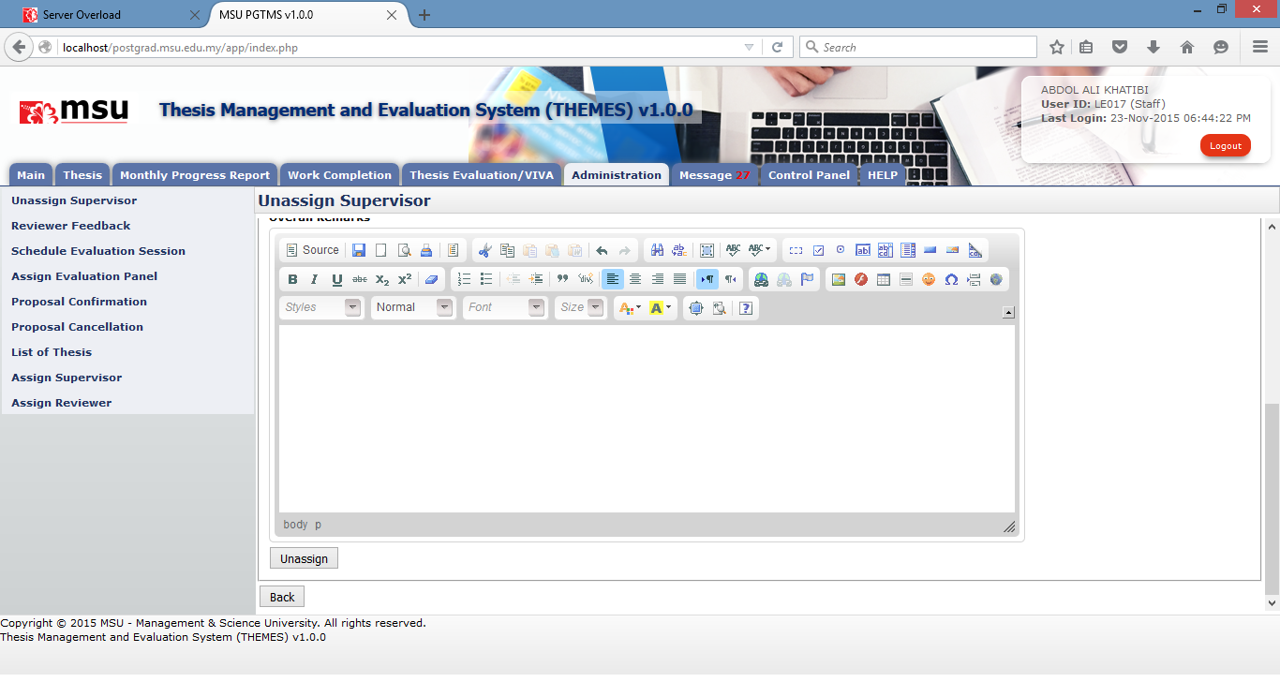

**8**

**7**

Figure 31: Unassign Supervisor

**Prerequisite**

The Faculty has assigned the Supervisor to the Student

**Steps**

1. Click on the **Administration** tab at the **Top Panel** section.
2. Click on the Unassign Supervisor at the **Left Panel** section.
3. The list of student will be displayed on the **Working Area** section.
4. Find the student to unassign the Supervisor and click on the **Unassign** link.
5. The list of Supervisor for the selected student will be displayed. You may view the Supervisor brief biodata or enter specific remark for this Supervisor.
6. Tick the checkbox of the selected Supervisor to be unassigned.
7. Enter the reason on the **Overall Remarks** text field if you have it.
8. Click **Unassign** button once you have confirm to unassign the Supervisor from the student.

**Next Action**

The Faculty User is needed to re-assign another Supervisor or Co-Supervisor to supervise the student.

**Warning**

The system will prompt a notification message if the checkbox is unselected before the submission.

**Note**

None

## Proposal Confirmation

Proposal Confirmation page will list all the thesis proposal that being proposed by the Student to the Faculty for review and approval decision. At this stage the Faculty can also recommend the right Supervisor / Co-supervisor to supervise the student for their thesis including the Reviewer.

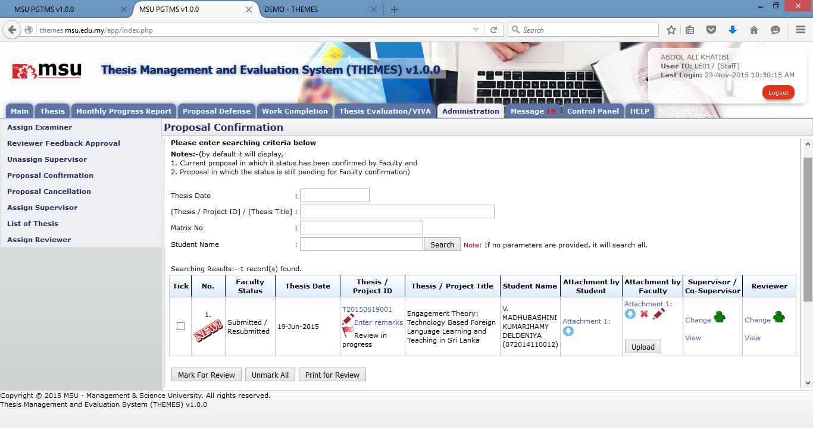

**8**

**8**

**7**

**6**

**5**

**4**

**3**

**2**

**1**

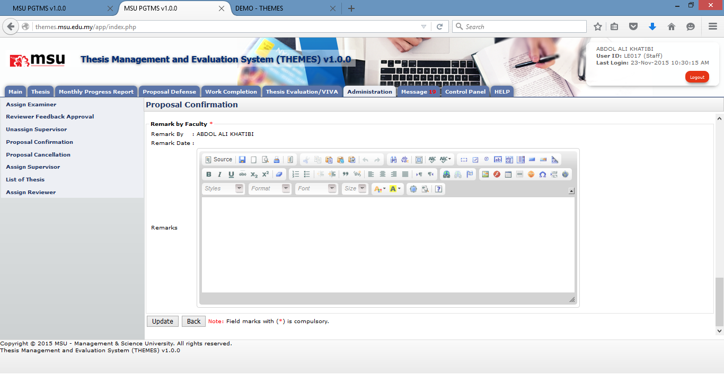

**9**

**9**

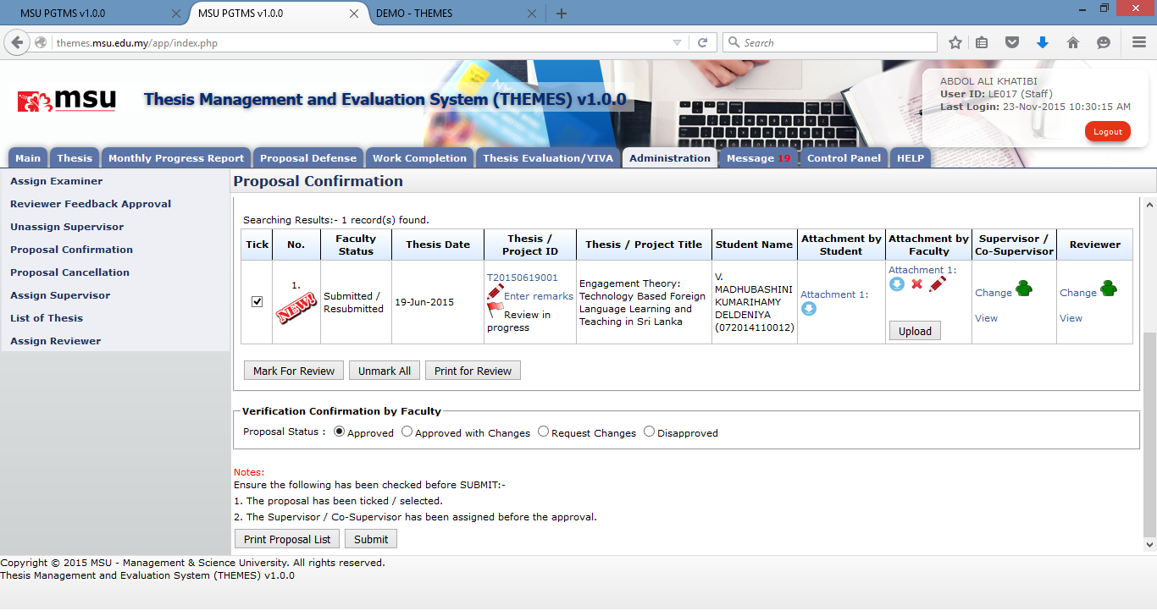

**12**

**13**

**10**

**10**

**10**

**11**

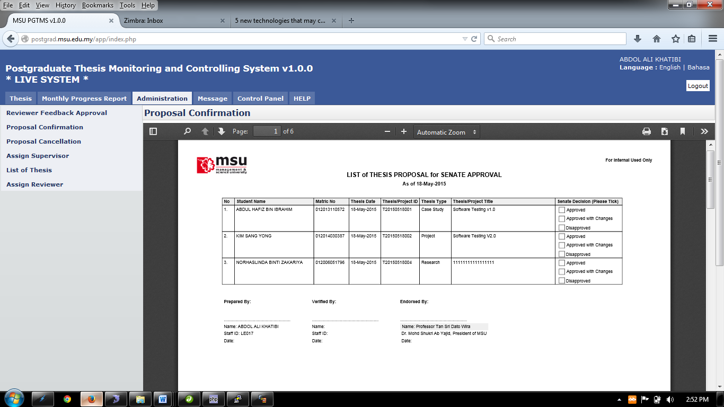

**11**

Figure 32: Administration Tab – Proposal Confirmation

**Prerequisite**

The student has submitted the thesis proposal to the Faculty.

**Steps**

1. Click on the **Administration** tab on the system **Top** **Panel** section.
2. Click on the **Proposal Confirmation** menu on the system **Left** **Panel** section.
3. The searching page will be displayed on the **Working Area** section. Enter the searching criteria to find the specific result or just click the **Search** button to list all available result.
4. The search result will be populated under the searching result table.
5. Click the **Thesis ID** link if to view the detail of the thesis proposal.
6. Click the attachment link if to download and view the attachment submitted by the student.
7. Click **Upload** button if to upload the attachment related the thesis proposal. Once uploaded you have an option to remove it from the list.
8. Before thesis proposal can be confirmed, the Faculty may need to forward the thesis proposal to the reviewer to get their feedback. Each of these thesis proposals which are being reviewed can be indicated via its status.
   1. Tick the respective checkbox and click on the **Mark for Review** button. The thesis proposal will be indicated as **Review in Progress**.
   2. Click **Unmark All** button if to remove the **Review in Progress** status from the list.
   3. Click on **Print for Review** button if to print the list for distribution to the identified Reviewer.
9. This page will be displayed once you have clicked the **Thesis ID** link. You can enter your remarks here and click the **Update** button to save it.
10. For thesis proposal confirmation,
    1. Tick the checkbox for the respective thesis
    2. Select the confirmation option **Approved, Approved with Changes, Request Changes** or **Disapproved**.
    3. Click the **Submit** button to confirm the thesis proposal status
11. You can also print the list of thesis proposal via **Print Proposal List** button which the sample of PDF file is as shown above.
12. Assign Supervisor can be done at any time. The steps to assign Supervisor can be referred to the **Assign Supervisor** section.
13. Assign Reviewer can be before the thesis proposal is confirmed by the Faculty. The steps to assign Reviewer can be referred to the **Assign Reviewer** section.

**Next Action**

If the thesis proposal confirmation status is **Approved** or **Approved with Changes** then the Senate needs to confirm the status of thesis proposal too.

If the thesis proposal confirmation status is **Request Changes** then the Student need to amend it and resubmit back to the Faculty.

If the thesis proposal confirmation status is **Disapproved** then the Student need to resubmit a new thesis proposal to the Faculty.

**Warning**

The system will prompt a notification message if the thesis proposal confirmation status is unselected before the submission.

**Note**

None

## Proposal Cancellation

Proposal Cancellation is a feature provided to the Faculty to approve the cancellation request to the submitted proposal by the student. This will enable the student to do the required changes before it can be resubmitted again.

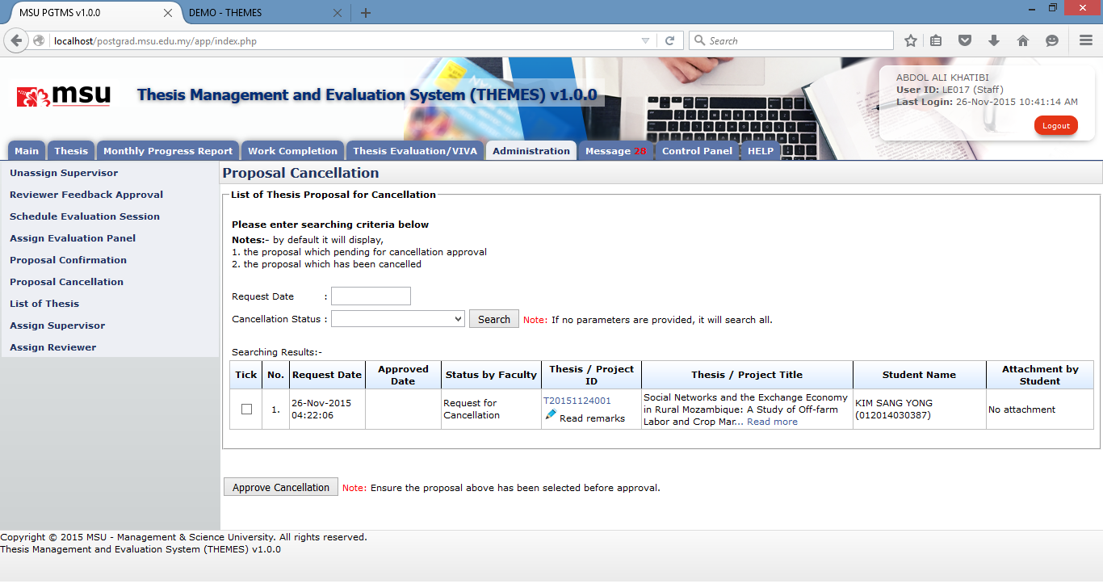

**3**

**8**

**7**

**4**

**2**

**1**

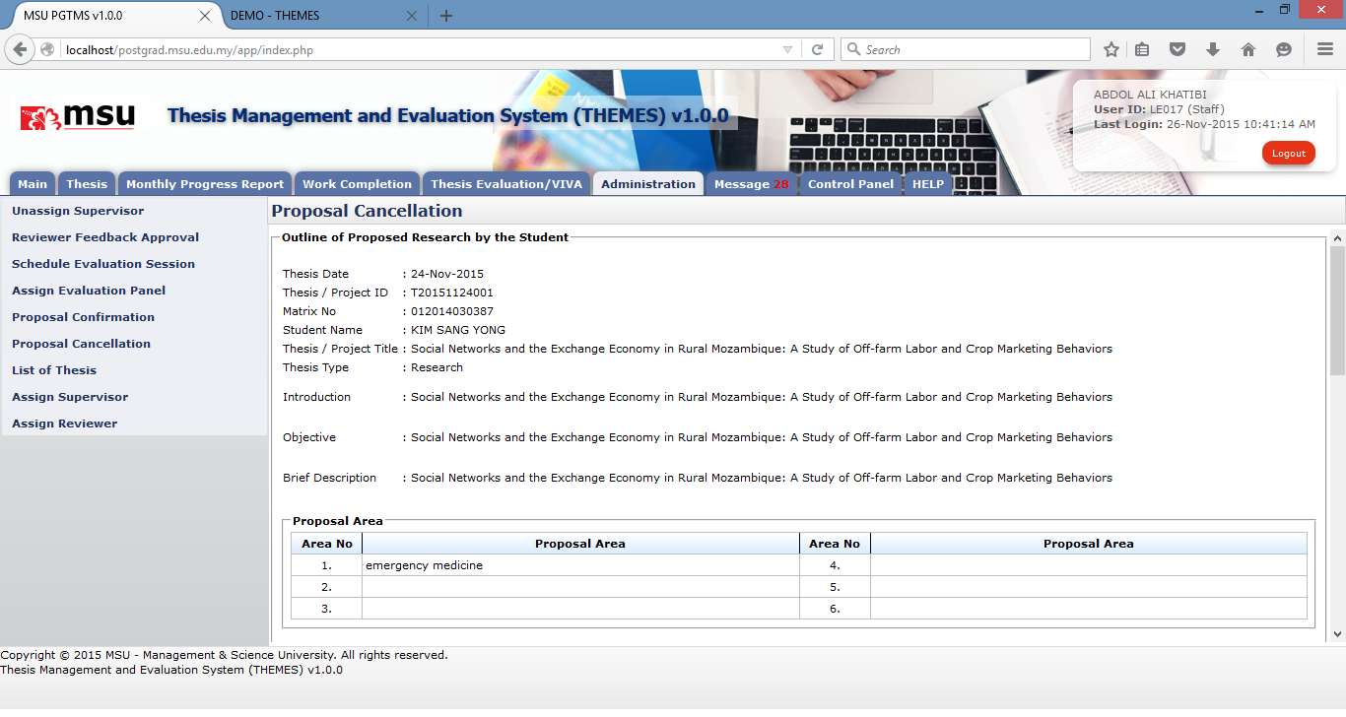

**5**

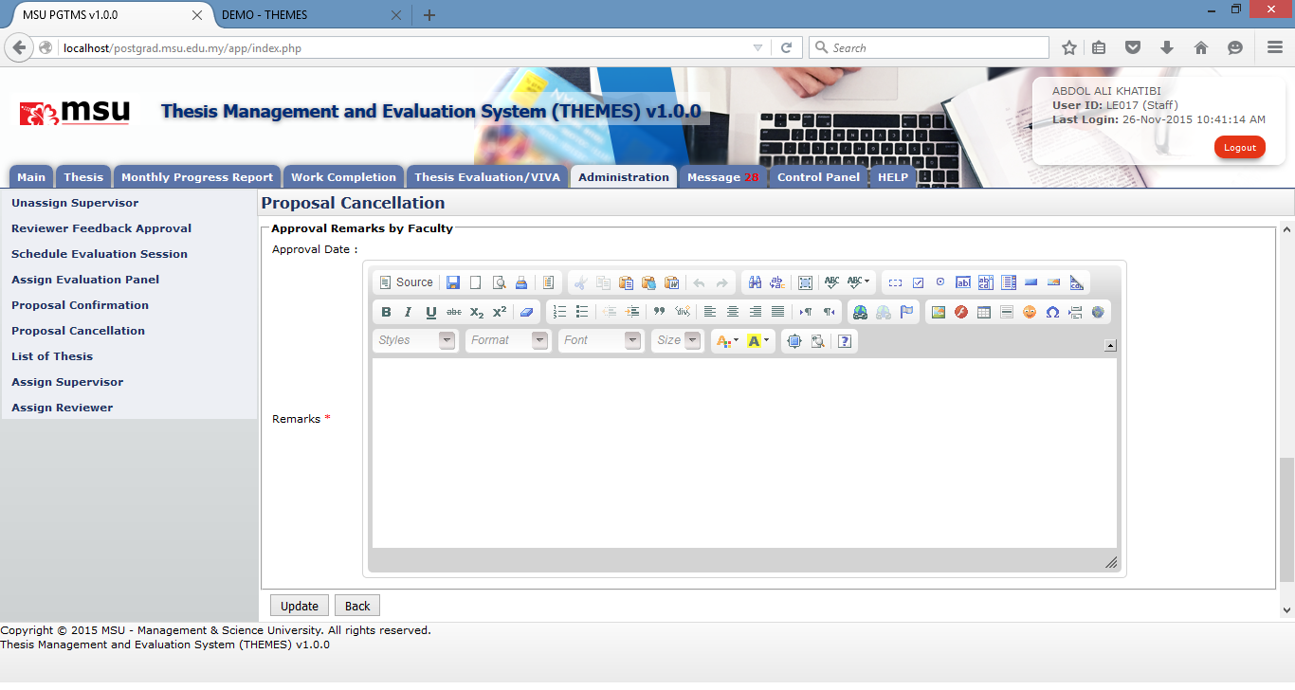

**6**

**5**

Figure 33: Administration Tab – Proposal Cancellation

**Prerequisite**

The student has applied the request to cancel the thesis proposal.

**Next Action**

Student is to resubmit the thesis proposal after the amendment done.

**Steps**

1. Click on the **Administration** tab on the system **Top** **Panel** section.
2. Click the **Proposal Cancellation** menuon the system **Left** **Panel** section.
3. Enter the searching criteria if to find the specific result or just click on the **Search** button to find the general result.
4. The list of thesis proposal will be displayed under the search result. Click on the **Thesis ID** link to get the next page to enter the remarks.
5. The page will display the thesis proposal information and request the Faculty User to enter the remarks.
6. Click on the **Update** button to save the change and **Back** button to go back to the previous page.
7. Tick the checkbox which the thesis proposal is going to be cancelled.
8. Click the **Approve Cancellation** button to confirm the cancellation.

**Next Action**

The student is do the thesis proposal amendment and resubmit back to the Faculty.

**Warning**

System will prompt a notification message if the checkbox is untick before the submission to approve the cancellation request.

**Note**

None

## Assign Reviewer

### Assign Reviewer

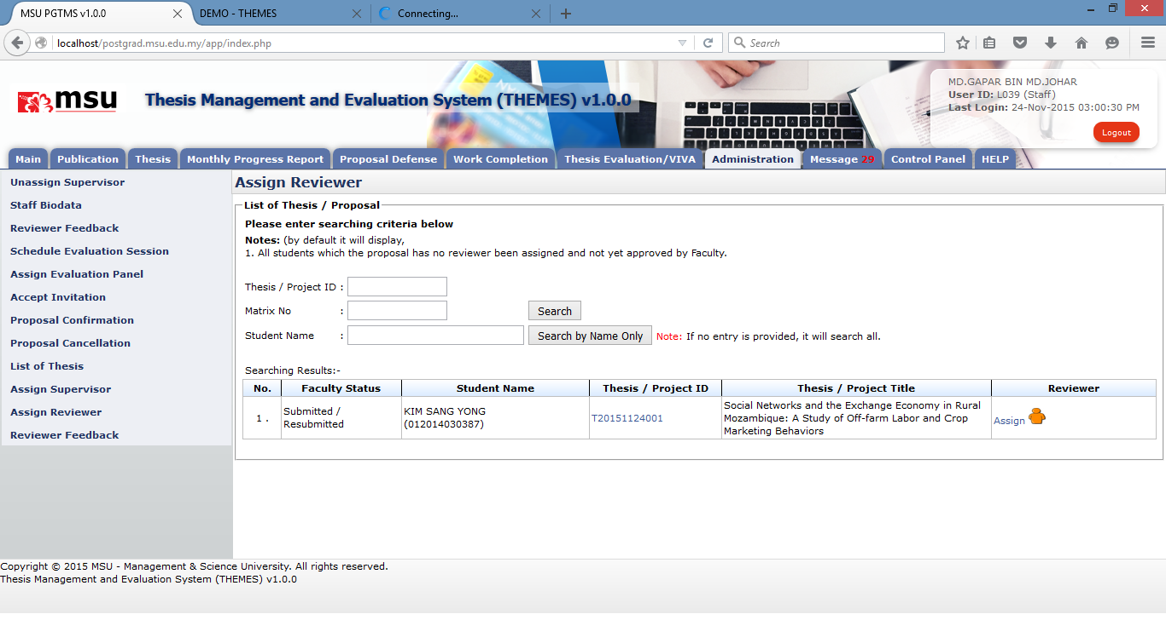

**4**

**3**

**2**

**1**

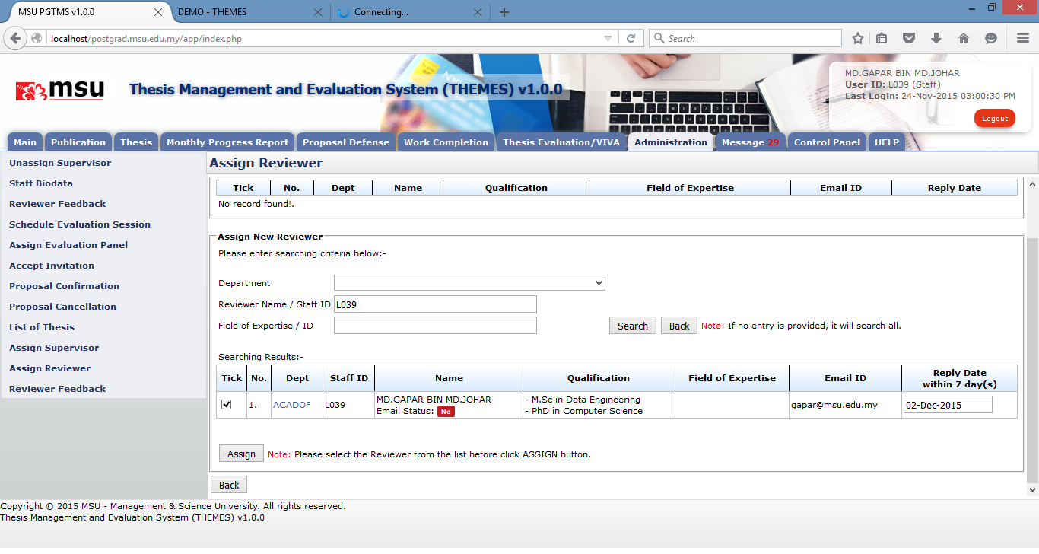

**7**

**6**

**5**

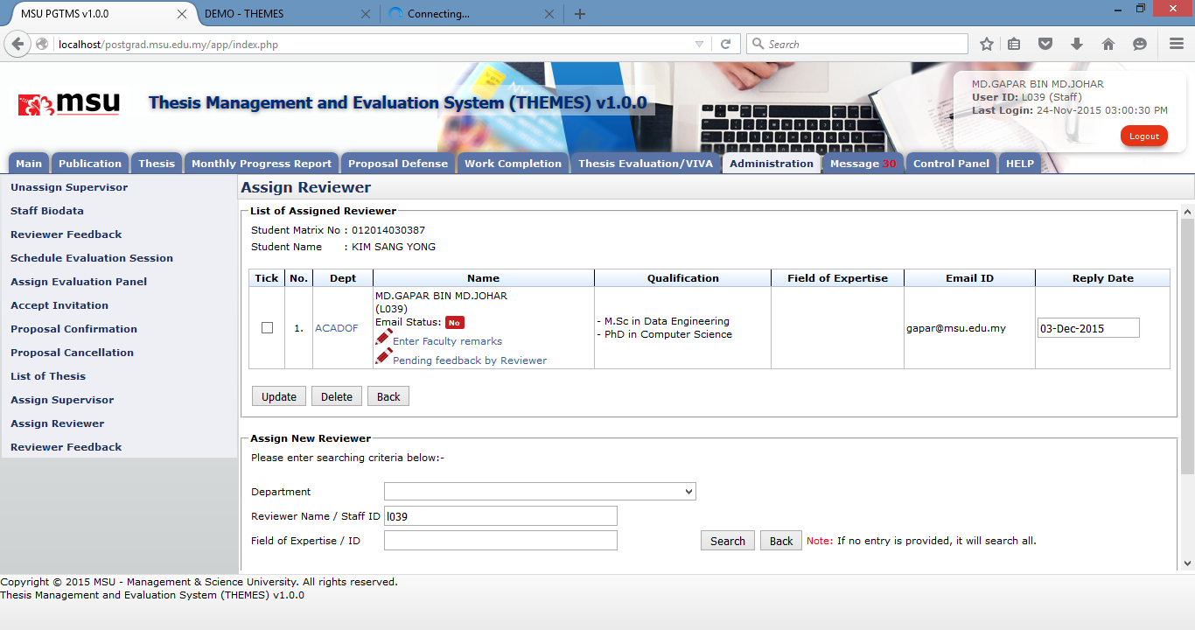

**10/11**

**11**

**9**

**11**

**10**

**8**

Figure 34: Assign Reviewer

**Prerequisite**

Student submit new thesis proposal

**Steps**

1. Click on the **Administration** tab on the **Top** **Panel** section.
2. Click on the **Assign Reviewer** menu on the **Left** **Panel** section. The list of thesis proposal will be displayed on the **Working Area** section.
3. Enter the searching criteria if to search specific result or just click on the **Search** button to search general result.
4. The list of student will be displayed on the table. Find the student and click the **Assign/Change** link to assign the Reviewer to the student. The **Assign** link indicates the staff is yet to be assigned as Reviewer. The **Change** link indicates the staff is already assigned as Reviewer.
5. The Assign Reviewer page will be displayed. Enter the searching criteria if to search specific result or just click on the **Search** button to search general result
6. The list of staff will be displayed on the table. Find the staff; change the default **Reply Date** if it is needed, and tick the respective checkbox.
7. Click on the **Assign** button to assign the staff as reviewer to the student.
8. The selected Reviewer will be populated into the list.
9. Enter the specific remarks for this Reviewer (if any) via the **Enter Faculty remarks** link.
10. If you want to delete the Reviewer, tick the checkbox. It can be in multiple rows. Click the **Delete** button to delete the **Reviewer** from the list.
11. If you want to update the **Reply Date**, change it, tick the checkbox and click the **Update** button to save the change.

**Next Action**

The Reviewer is to review and provide the feedback.

**Warning**

System will prompt a notification message if the Student

1. Submit the amendment without confirm all the required changes.
2. Resubmit the amendment

**Note**

None

### Assign Reviewer via Proposal Confirmation

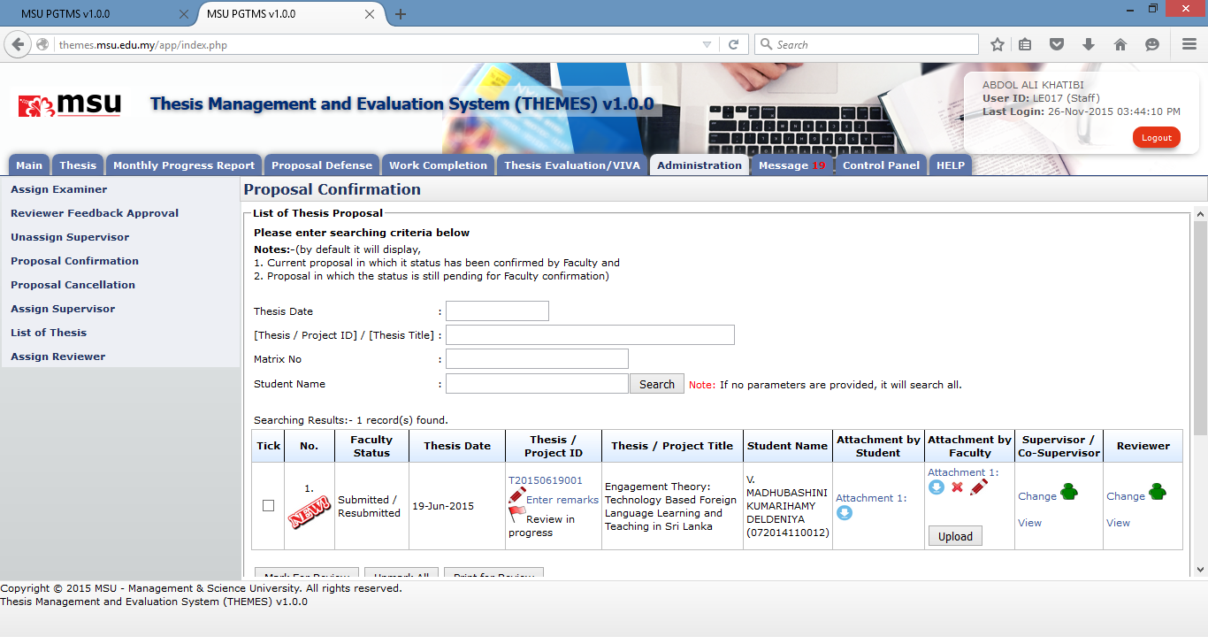

**4**

**3**

**2**

**1**

Figure 35: Assign Reviewer via Proposal Confirmation

**Prerequisite**

Student submit new thesis proposal

**Steps**

1. Click on the **Administration** tab on the system **Top** **Panel** section.
2. Click on the **proposal Confirmation** menu on the system **Left** **Panel**.
3. Enter the searching criteria if to find the specific result or just click the **Search** button to list all the result.
4. The searching results will be displayed under the searching result table. Click on the **Assign/Change** link to assign the Reviewer to the student. The **Assign** link indicates the staff is yet to be assigned as Reviewer. The **Change** link indicates the staff is already assigned as Reviewer. The next following steps please follow the same steps as described in **Assign Reviewer** section.

**Next Action**

The Reviewer is to review and provide the feedback.

**Warning**

System will prompt a notification message if the Student

1. Submit the amendment without confirm all the required changes.
2. Resubmit the amendment

**Note**

None

## Assign Supervisor

### Assign Supervisor

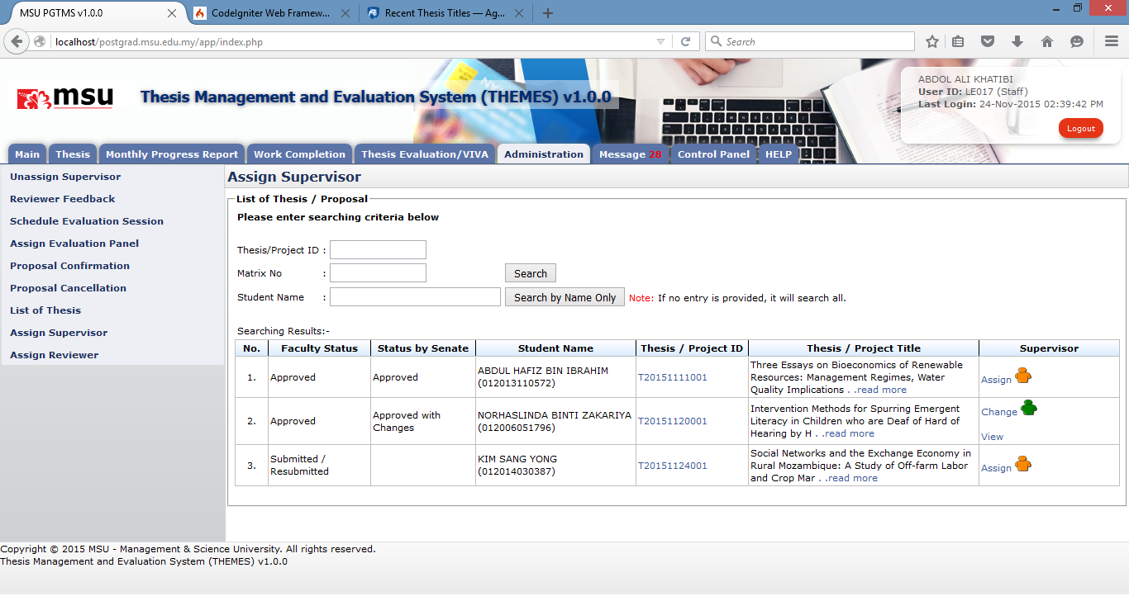

**19**

**4**

**2**

**3**

**1**

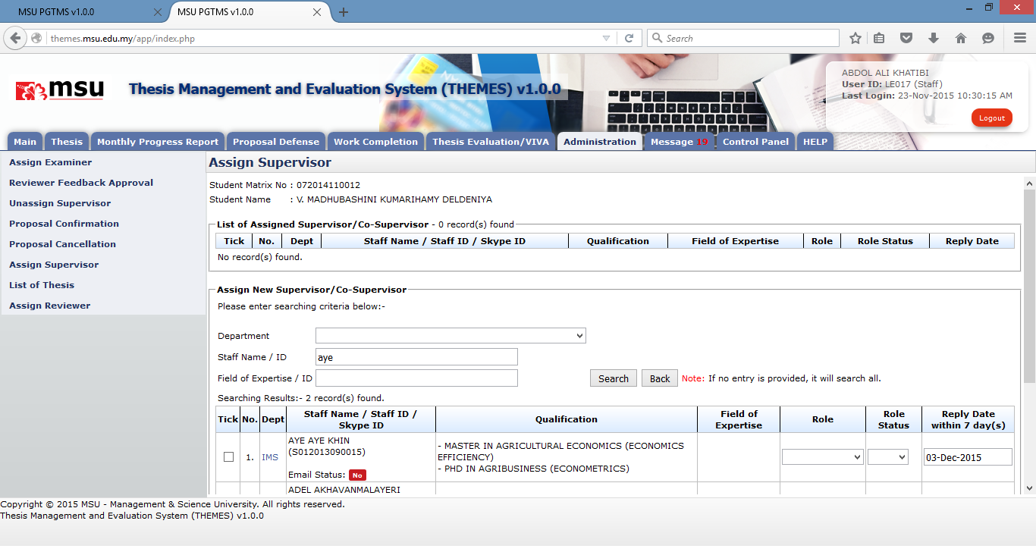

**6**

**5**

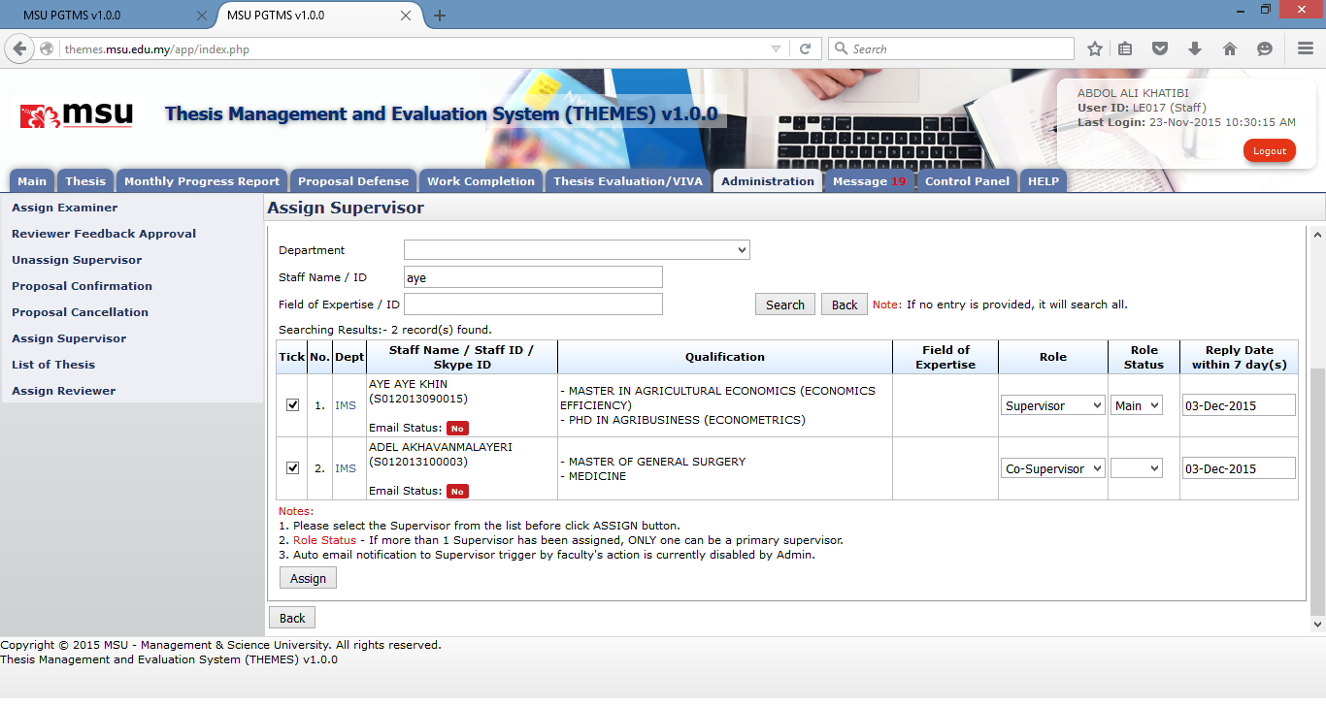

**9**

**8**

**7**

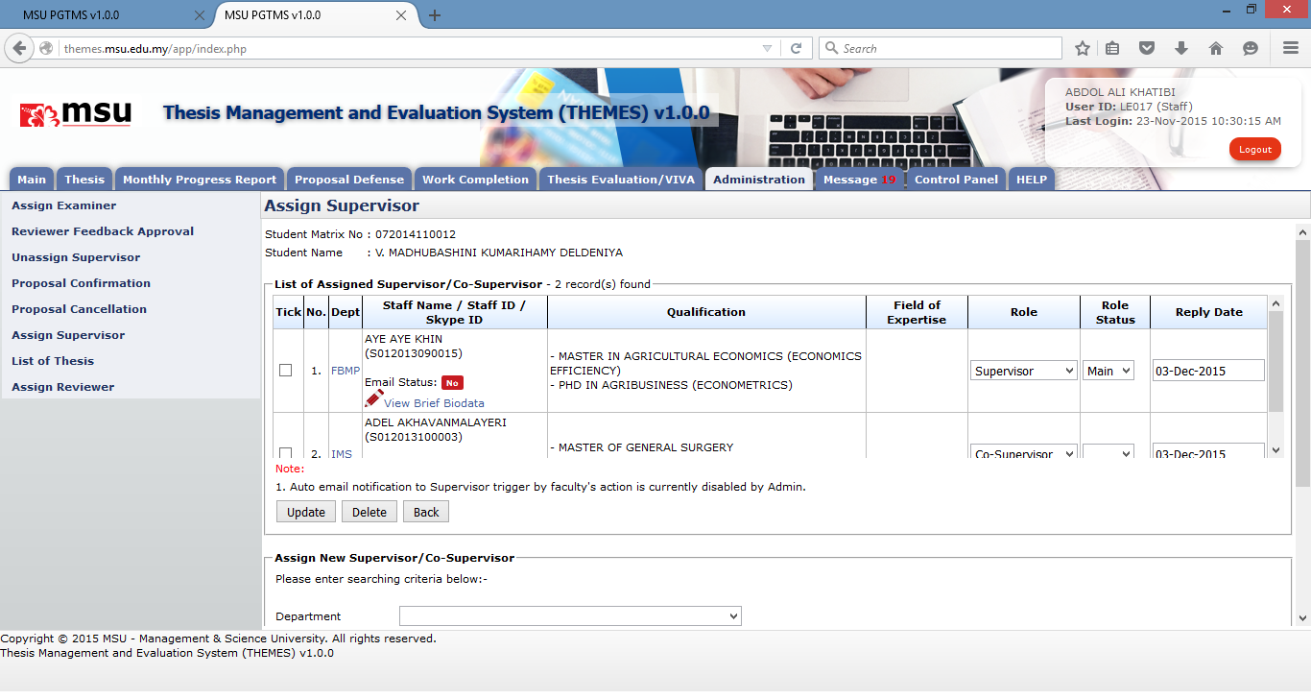

**15**

**12**

**14**

**13**

**11**

**10**

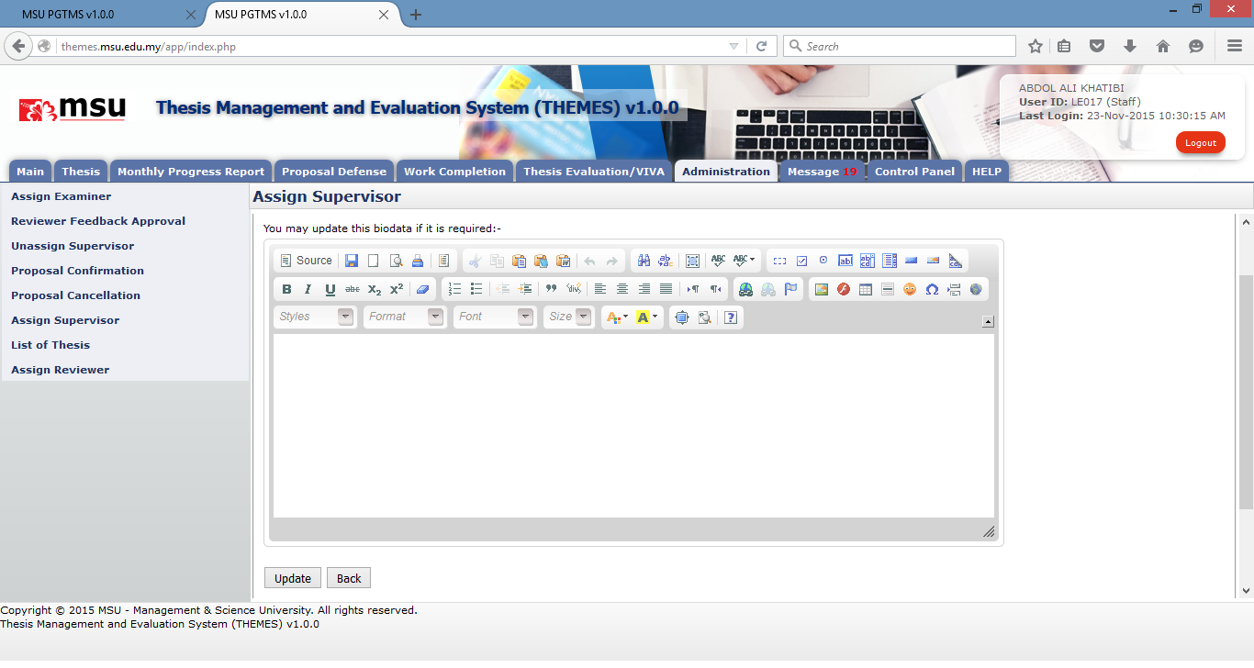

**17**

**16**

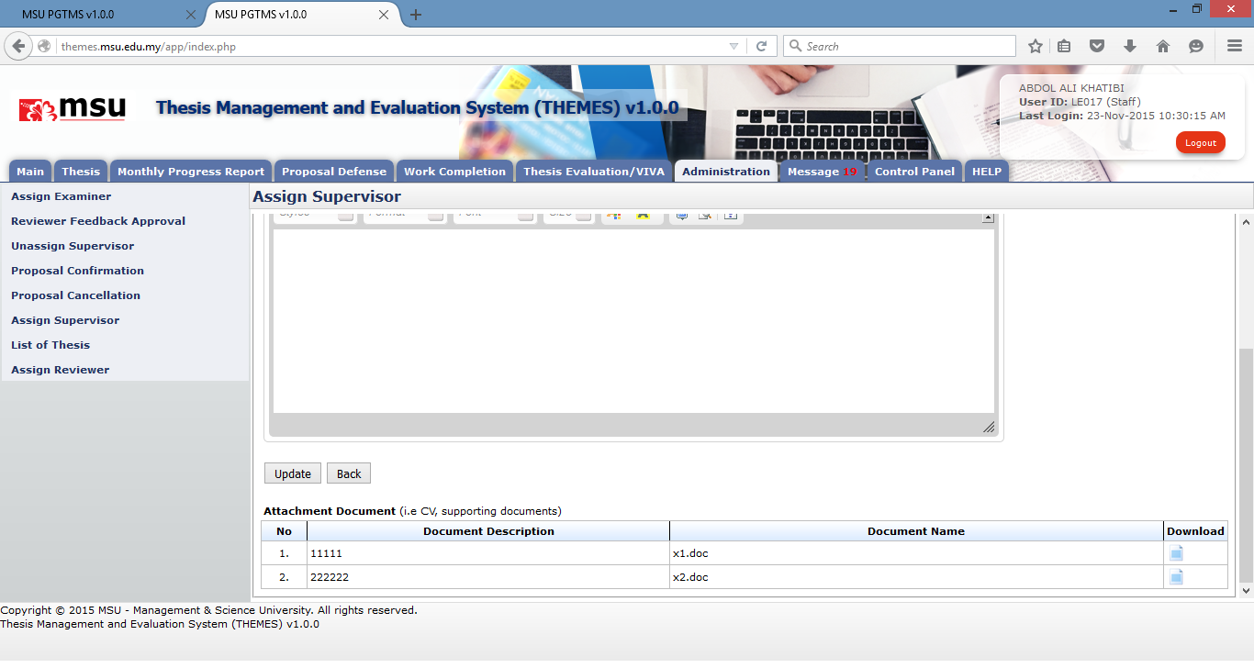

**18**

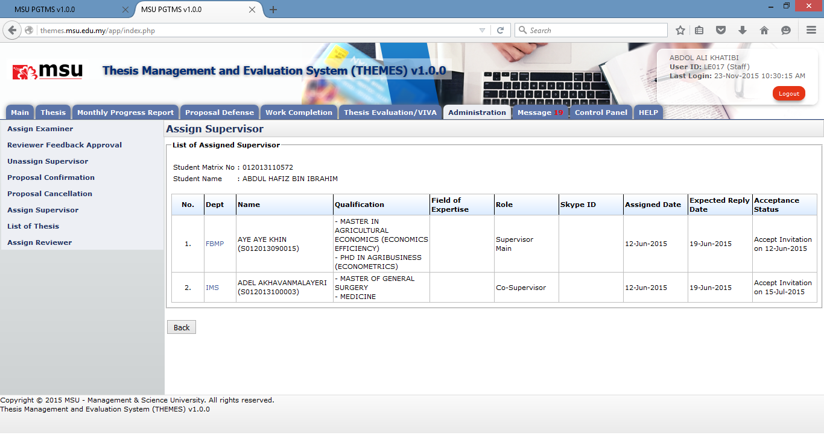

**20**

Figure 36: Administration Tab – Assign Supervisor Page

**Prerequisite**

Student has submitted the thesis proposal

**Steps**

1. Click on the **Administration** tab on the system **Top** **Panel** section.
2. Click on the **Assign Supervisor** menu on the system **Left** **Panel**.
3. Enter the searching criteria if to find the specific result or just click the **Search** button to list all the result.
4. The searching results will be displayed under the searching result table. Click the **Assign/Change** link to assign the Supervisor / Co-Supervisor to the student. The **Assign** link indicates the staff is yet to be assigned as Supervisor / Co-Supervisor. The **Change** link indicates the staff is already assigned as Supervisor / Co-Supervisor.
5. The next following page will be displayed. Enter the searching criteria if to find the specific result or just click the **Search** button to list all the result.
6. The searching results will be displayed under the searching result table.
7. Find the staff to be assigned as Supervisor / Co-Supervisor. Assign the **Role** and **Role Status**. The default **Reply** **Date** is also provided but the Faculty can change if it is needed **Role**.
8. Tick the respective checkbox
9. Then click the **Assign** button.
10. The newly assigned Supervisor will be listed in the **List of Assigned Supervisor/Co-Supervisor**.
11. If any change required to **Role, Role Status** or **Reply Date**, do the changes.
12. Tick the respective checkbox.
13. Click **Update** button to save the changes.
14. If need to delete the assigned staff, tick the respective checkbox and click **Delete** button.
15. If to view the Supervisor / Co-Supervisor brief biodata, click on the **View Brief Biodata**.
16. The biodata page will be displayed. Update the biodata if it is needed.
17. Click Update button to save the changes.
18. If to view the attached document, click the download image and download it.
19. Click **View** link if to view the list of Supervisor/Co-Supervisor which has been assigned to the student.
20. The next following page will be displayed which shows the list of assigned Supervisor / Co-Supervisor.

**Next Action**

The Faculty user can confirm the status of the thesis proposal.

**Warning**

None

**Note**

None

### Assign Supervisor via Proposal Confirmation

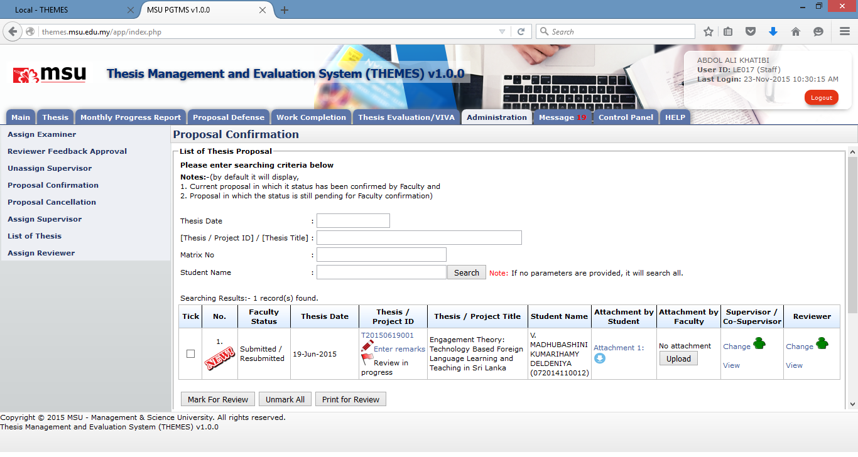

**3**

**4**

**2**

**1**

Figure 37: Administration Tab – Assign Supervisor via Proposal Confirmation

**Prerequisite**

Student has submitted the thesis proposal

**Steps**

1. Click on the **Administration** tab on the system **Top** **Panel** section.
2. Click on the **proposal Confirmation** menu on the system **Left** **Panel**.
3. Enter the searching criteria if to find the specific result or just click the **Search** button to list all the result.
4. The searching results will be displayed under the searching result table. Click the **Assign/Change** link to assign the Supervisor / Co-Supervisor to the student. The **Assign** link indicates the staff is yet to be assigned as Supervisor / Co-Supervisor. The **Change** link indicates the staff is already assigned as Supervisor / Co-Supervisor. The next following steps please follow the same steps as described in **Assign Supervisor** section.

**Next Action**

The Faculty user can confirm the status of the thesis proposal.

**Warning**

None

**Note**

None

## List of Thesis Proposal – Disapproved

**1**

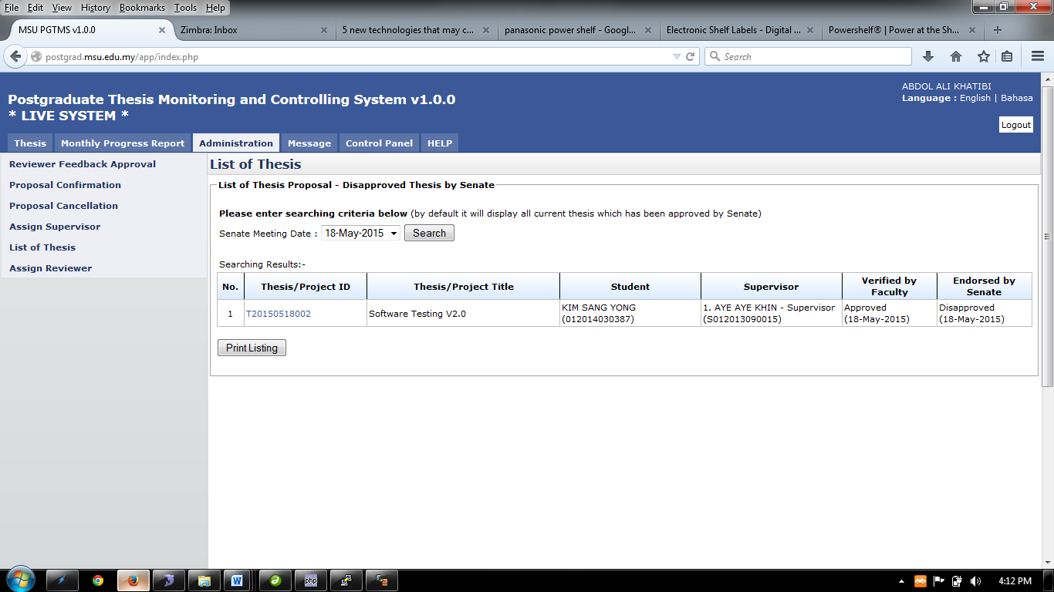

**4**

**3**

**2**

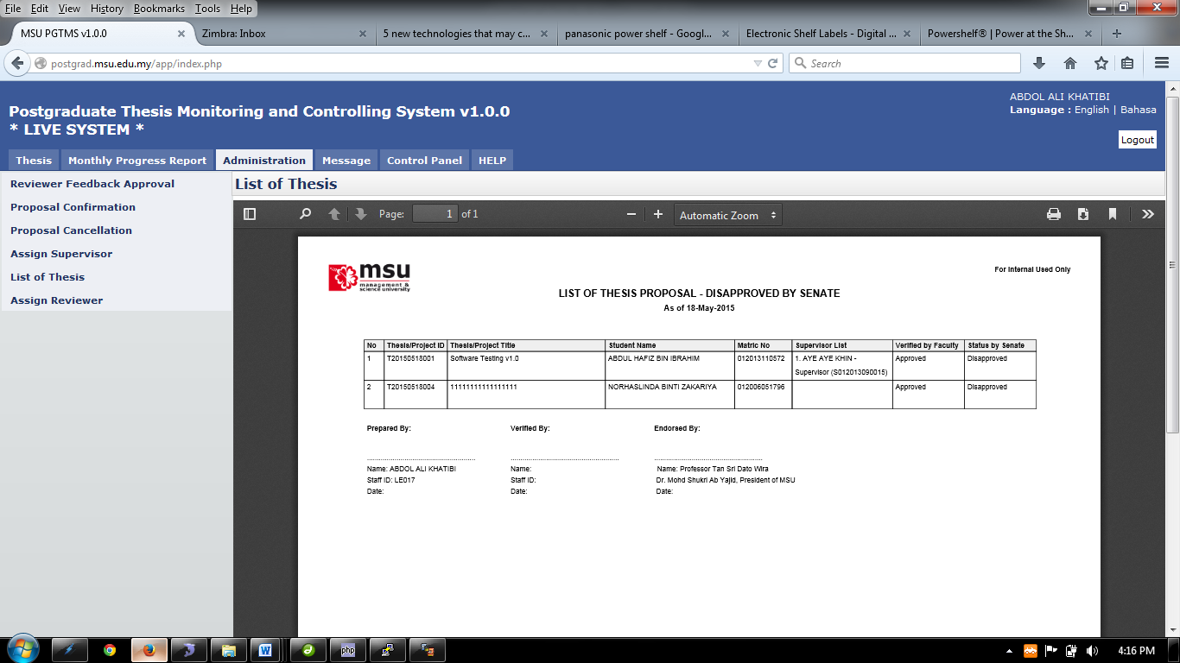

**6**

Figure 38: Administration Tab – List of Disapproved Thesis

**Pre-condition**

Senate has disapproved the thesis proposal submitted by the Student.

**Steps**

1. Click on the **Administration** tab on the system **Top** **Panel** section.
2. Click on the **List of Thesis** menu on the system **Left** **Panel** section.
3. The List of Thesis page will be displayed on the **Working Area** section. Select the **Senate Date** if to find the specific result or leave it empty to find general result. Click **Search** button.
4. The result will be displayed under the **Searching Result** table. Click on the **Print Listing** button to generate a list of disapproved thesis.
5. The PDF file will be generated and it can be saved or printed out.

**Next Action**

Student needs to resubmit the thesis proposal.

**Warning**

None

**Note**

None.

# Message

## Inbox

### New and Read Message

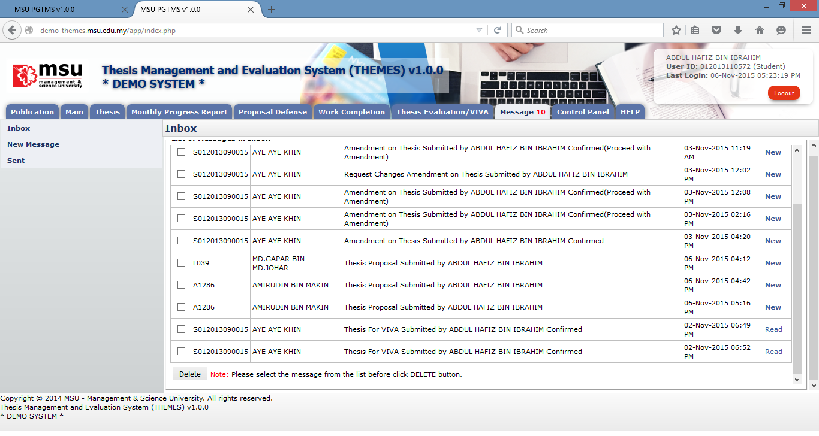

**3**

**2**

**1**

Figure 39: Message

**Prerequisite**

None

**Steps**

1. Click on the **Message** tab on the **Top** panel. If there is a number with it, that’s mean there are unread messages available pending action from the student.
2. Click on the **Inbox** menu on the **Left** panel. System will display the list of message on the **Working Area** section.
3. On the far right side, it will display the status of the message whether is **New** or **Read.** To read the message, click on it.
4. To delete message, tick on the checkbox in **Tick** column, and click **Delete** button

**Next Action**

None

**Warning**

None

**Note**

None.

### Delete Message



**4**

**3**

**2**

**1**

Figure 40: Delete Message

**Prerequisite**

None

**Steps**

1. Click on the **Message** tab on the **Top** panel. If there is a number with it, that’s mean there are unread messages available pending action from the student.
2. Click on the **Inbox** menu on the **Left** panel. System will display the list of message on the **Working Area** section.
3. Tick the checkbox in which the message is going to be deleted. It can be done in multiple rows.
4. Click on the **Delete** button to delete the message from the list.

**Next Action**

None

**Warning**

System will prompt a notification message if the checkbox is untick before the deletion.

**Note**

None

## New Message

### Send Message

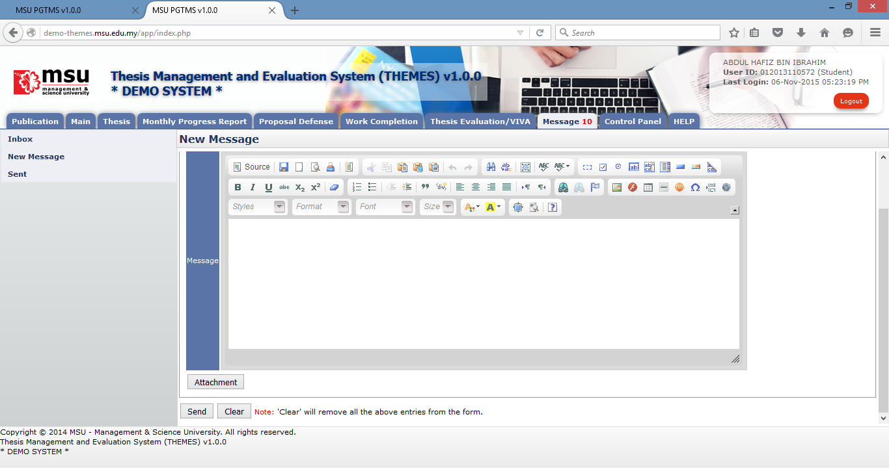

**3**

**2**

**1**

Figure 41: New Message

**Prerequisite**

None

**Steps**

1. Click on the **Message** tab on the **Top** panel
2. Click on the **New Message** menu on the **Left** panel
3. Once the Recipient, the message and the attachment (if any) are in place, then click **Send** button to send it to the Recipient.

**Next Action**

None

**Warning**

System will prompt a notification message if the checkbox is unticking before the deletion.

**Note**

None

### Select Recipient

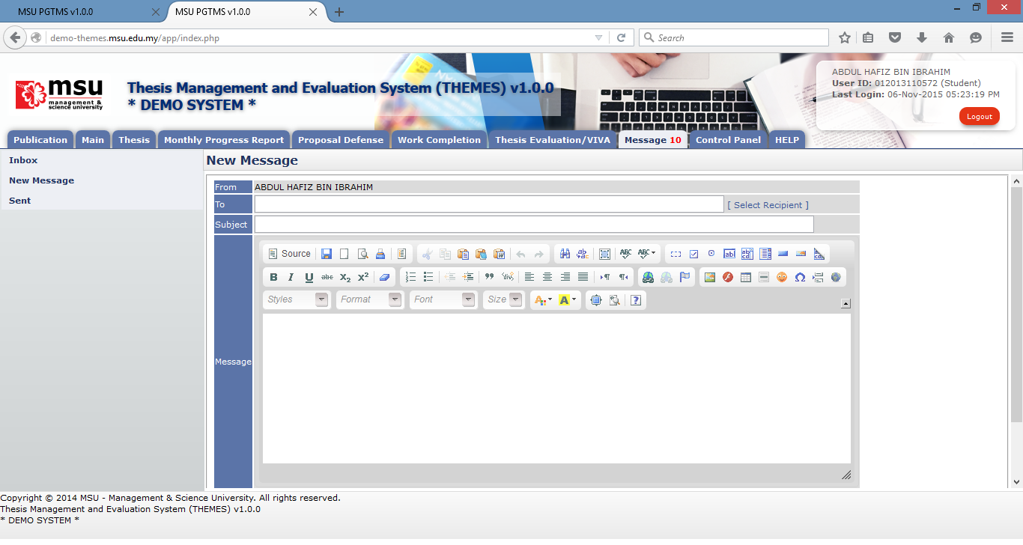

**1**

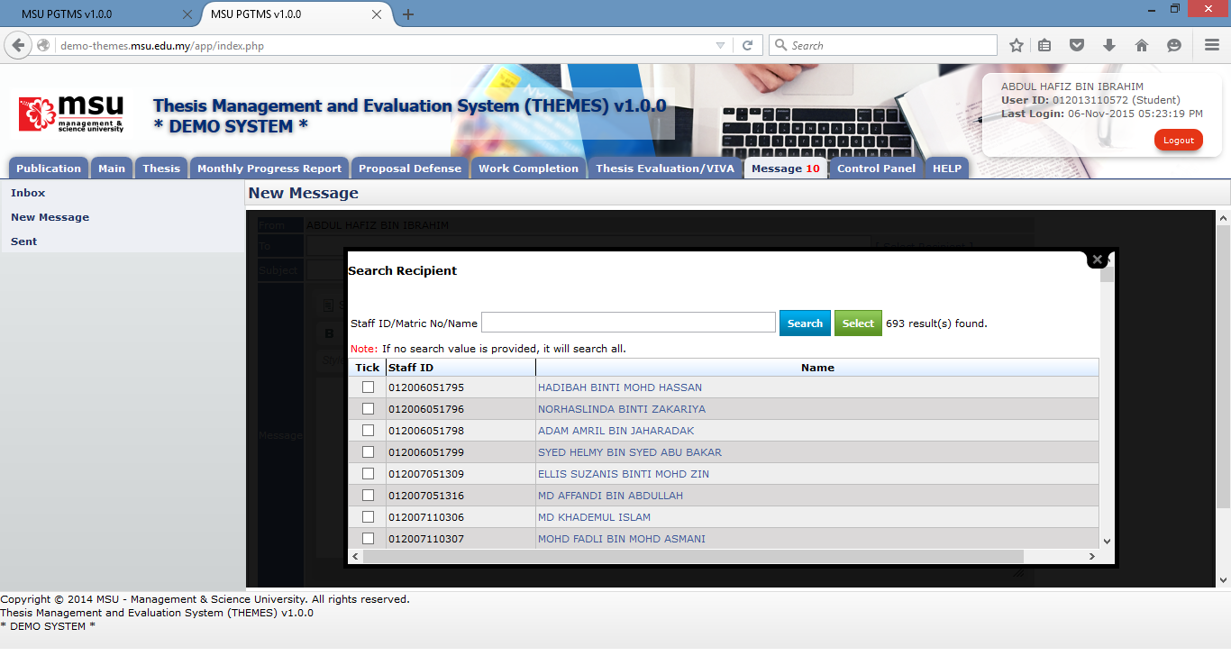

**4**

**2**

**3**

Figure 42: Select Recipient

**Prerequisite**

None

**Steps**

1. Click on the **Select Recipient** link to open the Recipient List page.
2. Enter the searching criteria and click **Search** button to search the specific search result or just click the **Search** button to search the general result.
3. Tick on the checkbox for the identified recipient.
4. Click on the **Select** button to populate the selected recipient into the **To** field on the New Message page.

**Next Action**

None

**Warning**

None

**Note**

None

### Upload Attachment - Add



**1**

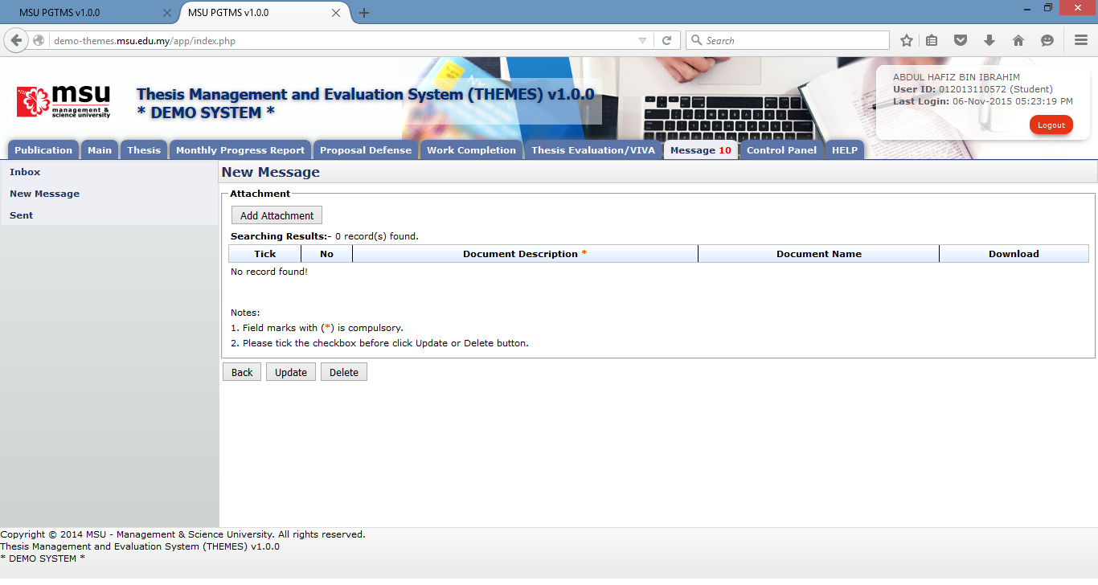

**2**

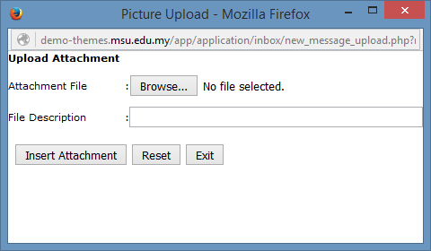

**4**

**3**

Figure 43: Upload Attachment - Add

**Prerequisite**

None

**Steps**

1. Click on the **Attachment** button to open the Attachment page.
2. On Attachment page, click on the **Add Attachment** button.
3. Click on the **Browse** button to select the attachment. File Description field is optional.
4. Click on the **Insert Attachment** button to add the select attachment into the attachment list.

**Next Action**

1. Send the message
2. Update the attachment’s description
3. Delete the attachment

**Warning**

None

**Note**

None

### Upload Attachment - Update

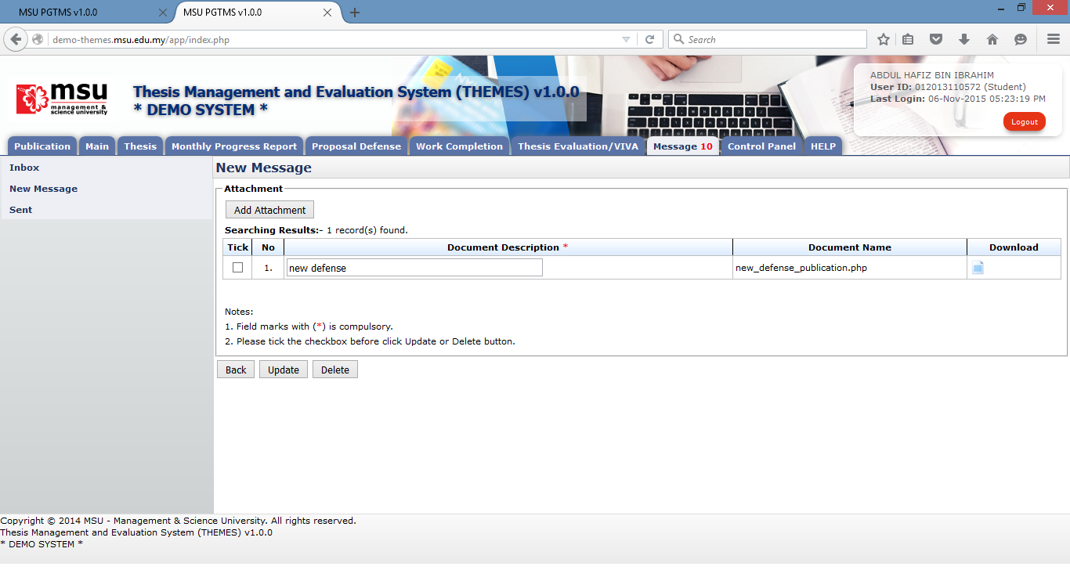

**3**

**1**

**2**

Figure : Upload Attachment - Update

**Prerequisite**

The attachment has been added into the attachment list.

**Steps**

1. Update the document’s description. It can be done in multiple rows.
2. Tick the checkbox for the document’s description being updated. It can be done in multiple rows.
3. Click on the **Update** button to update the changes.

**Next Action**

1. Send the message
2. Update the attachment’s description
3. Delete the attachment

**Warning**

None

**Note**

None

### Upload Attachment - Delete



**1**

**2**

Figure : Upload Attachment - Delete

**Prerequisite**

The attachment has been added into the attachment list.

**Steps**

1. Tick the checkbox for the document to be deleted. It can be done in multiple rows.
2. Click on the **Delete** button to delete the attachment from the list.

**Next Action**

1. Send the message
2. Add other new attachment
3. Delete other attachment

**Warning**

None

**Note**

None

## Sent Message

### View Sent Message

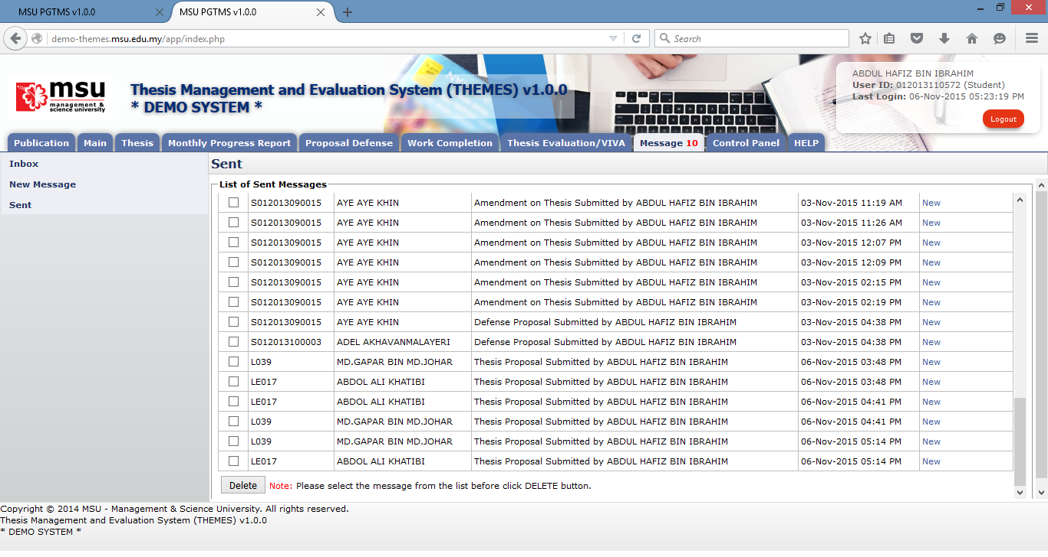

**1**

**3**

**2**

Figure 46: View Sent Message

**Prerequisite**

The message has been sent to the Recipient.

**Steps**

1. Click on the **Message** tab on the **Top Panel**.
2. Click on the **Sent** menu on the **Left Panel**.
3. To view the sent message, click on the message status

**Next Action**

None

**Warning**

None

**Note**

None

### Delete Sent Message



**3**

**1**

**4**

**2**

Figure 47: Delete Sent Message

**Prerequisite**

The message has been sent to the Recipient.

**Steps**

1. Click on the **Message** tab on the **Top Panel**.
2. Click on the **Sent** menu on the **Left Panel**.
3. Tick the checkbox for which the messages need to be deleted. It can be done in multiple rows.
4. Click on the Delete button to delete the messages from the list.

**Next Action**

None

**Warning**

None

**Note**

None

# Control Panel

## Change Password

### Before Login



**1**

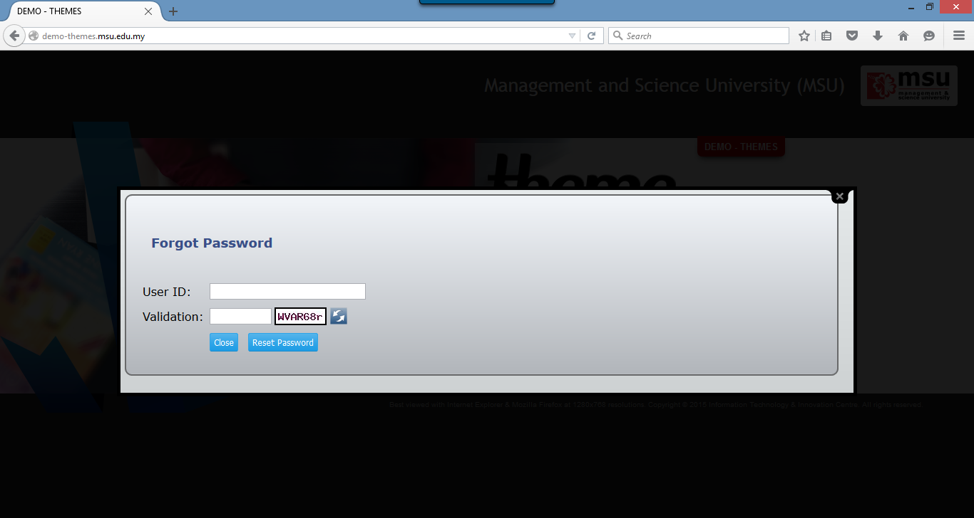

**3**

**2**

Figure 48: Change Password Page Before Login

**Prerequisite**

The User must have the email ID registered in KLAS2 system which failure to provide the valid email ID causing the system to do not generate and email a new reset password.

**Steps**

1. Click on the **Forgot Your Password** at the Login Page. The **Forgot Password** page will be displayed
2. Enter your **User ID** and **Validation Code**. The Validation Code can be refreshed if you want to change it.
3. Click on the **Reset Password** button. The system will generate the new password and send it to the registered user’s email ID.

**Warning**

System will prompt a message if no email ID found in KLAS2 system. The User needs to register it in KLAS2 first before request to reset the password.

**Note**

None.

### After Login

For the security reason, the user is strongly recommended to change the password at first successful login to the system.

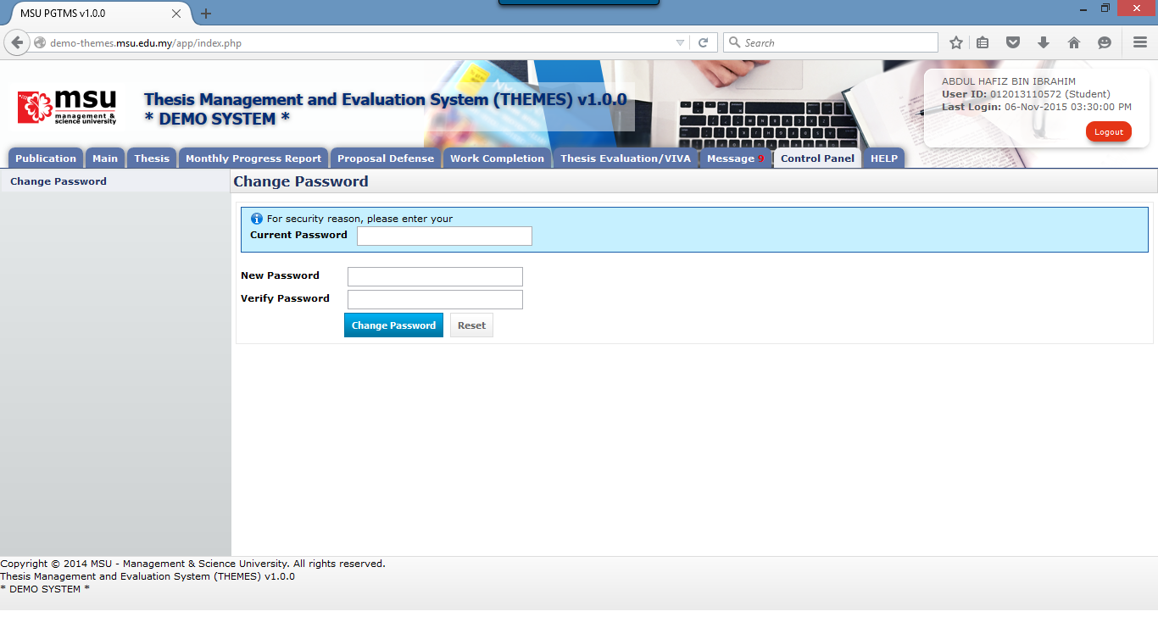

**6**

**5**

**4**

**3**

**2**

**1**

Figure 49: Change Password Page After Login

**Prerequisite**

None

**Steps**

1. Click on the **Control Panel** tab from the system **Top** panel section.
2. The **Change Password** menu will be displayed and click on it.
3. As security measure, the system will ask **Current Password** from the user.
4. Then follow by the **New Password** and **Verify Password**.
5. Click **Change Password** button to save the newly change password into the system successfully.
6. User can use **Reset** button if wanted to clear the entry on each fields.

**Warning**

1. If the provided **Current Password** is incorrect, the system will prompt an error message and the user needs to redo the above step 3 onwards.
2. If the provided **New Password** and **Verify Password** are mismatched, the system will prompt an error message and the user needs to provide the match password for both.
3. The user cannot reuse the last 3 passwords which have been used before.
4. The password shall have the numeric (0-9) and characters (a-z, A-Z)

**Note**

None.

# Help

## Online Help - Student

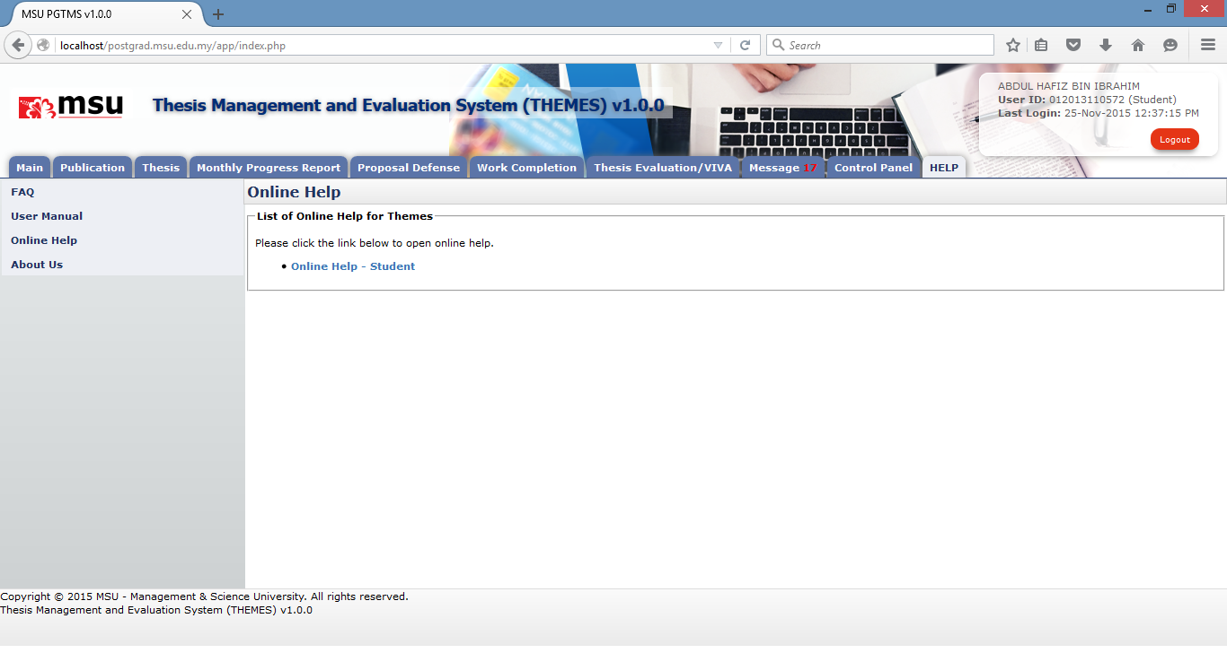

**2**

**3**

**1**

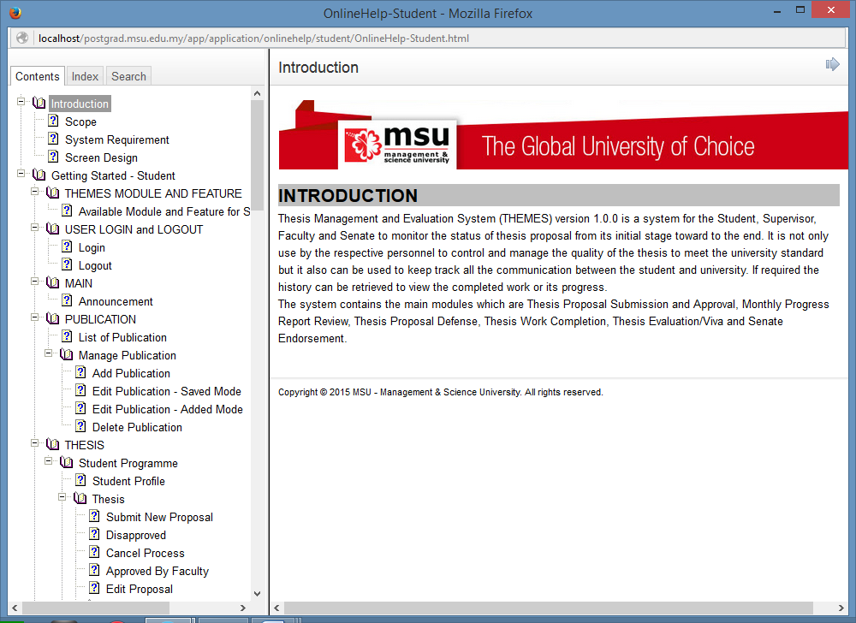

**4**

Figure 58: Online Help

**Prerequisite**

None

**Steps**

1. Click on the **HELP** tab from the system **Top** **Panel** section.
2. Click on the **Online Help** on the **Left Panel** section.
3. The online help will be displayed on the **Working Area** section which listed the applicable help to the Student. Click on the online help link.
4. The Online Help page will be displayed. The student can browse through the content to find the required help.

**Next Action**

None

**Warning**

None

**Note**

None.

## User Manual

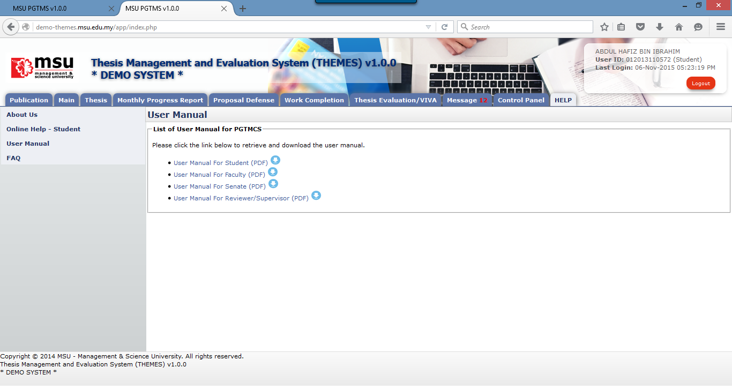

**3**

**2**

**1**

Figure 59: User Manual

**Prerequisite**

None

**Steps**

1. Click on the **Help** tab on the **Top** panel
2. Click on the **User Manual** menu on the **Left** panel
3. System will display the link to download user manual on the **Working Area** section.

**Next Action**

None

**Warning**

None

**Note**

None.

## Frequently Asked Question

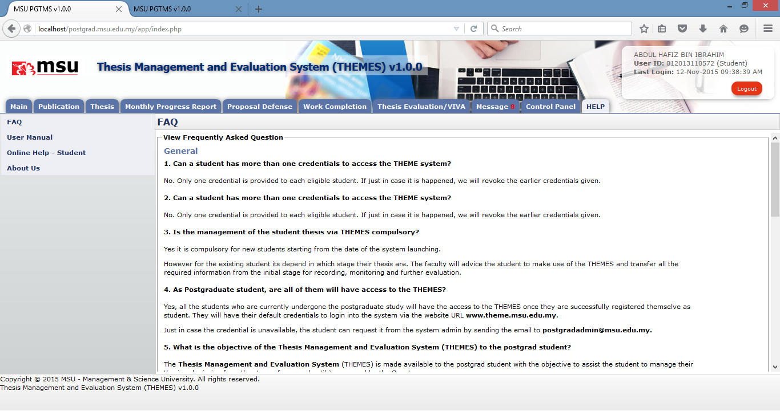

**2**

**1**

Figure 60: FAQ

**Prerequisite**

None

**Steps**

1. Click on the **Help** tab on the **Top** panel
2. Click on the **FAQ** menu on the **Left** panel
3. System will display the list of FAQ on the **Working Area** section.

**Next Action**

None

**Warning**

None

**Note**

None.

## About Us

The page where indicate the current system’s version and email to send comment and report bugs.

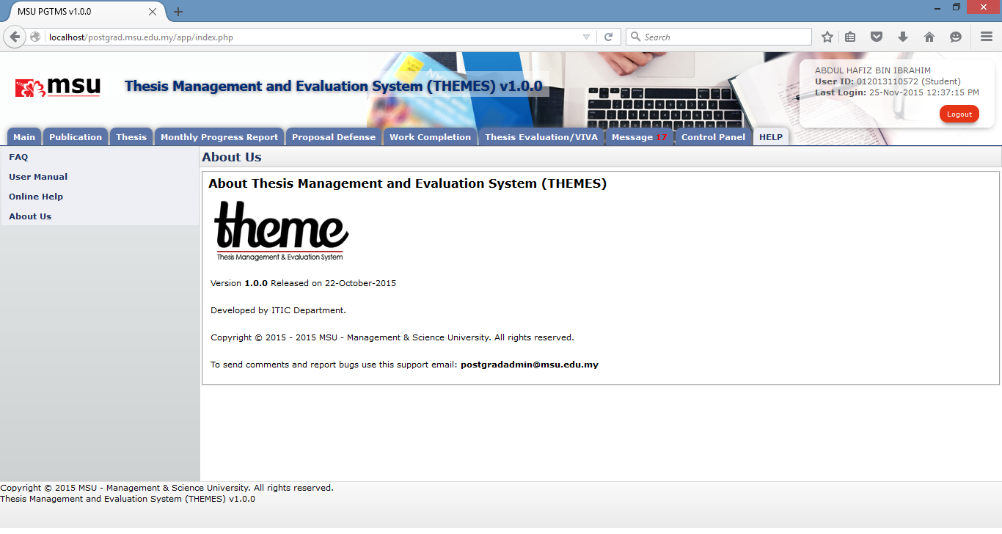

**3**

**2**

**1**

**Prerequisite**

None

**Steps**

1. Click on the **Help** tab on the **Top** panel
2. Click on the **About Us** menu on the **Left** panel
3. System will display the About Us information on the **Working Area** section.

**Next Action**

None

**Warning**

None

**Note**

None.

This page is intentionally left blank.